CAS Competitive Grant Application
Coaching support for
special education administrators

Connecticut Association of Schools
Contact: Marie Salazar Glowski
E-Mail: mglowski@casciac.org

Due Date: 11/20/2018

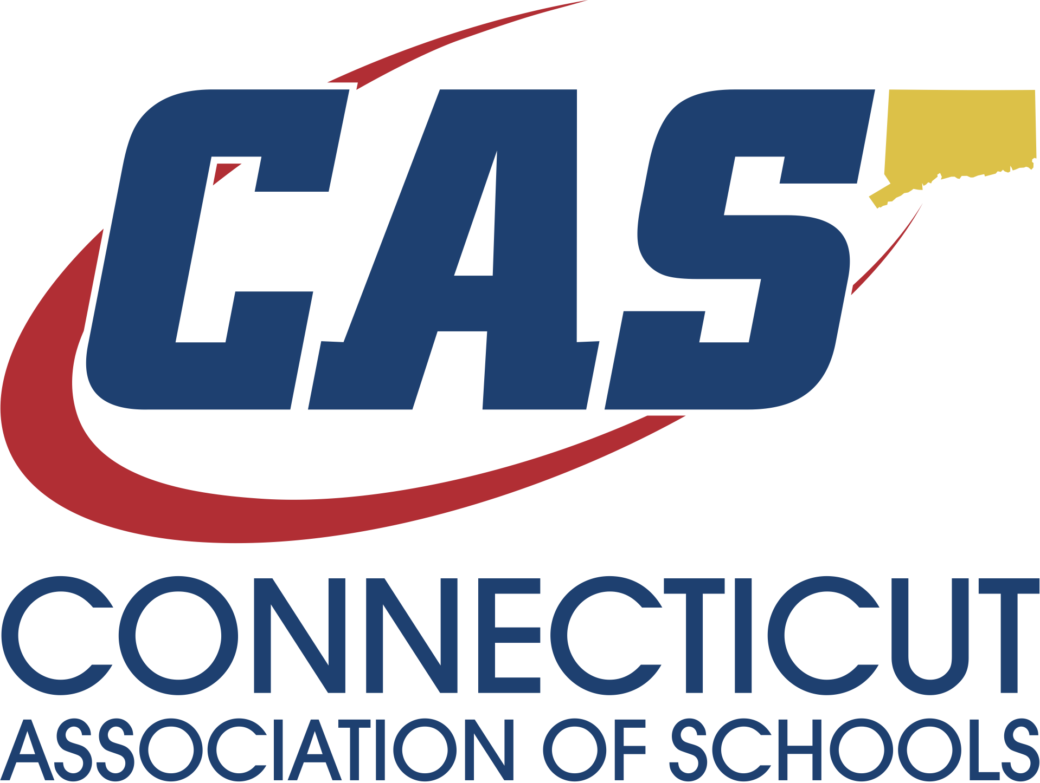

Affirmative Action Statement

The Connecticut Association of Schools is committed to a policy of equal opportunity/affirmative action for all qualified persons. The Department of Education does not discriminate in any employment practice, education program, or educational activity on the basis of race, color, religious creed, sex, age, national origin, ancestry, marital status, sexual orientation, gender, gender identity or expression, disability (including, but not limited to, intellectual disability, past or present history of mental disorder, physical disability or learning disability), genetic information, or any other basis prohibited by Connecticut state and/or federal nondiscrimination laws. The Department of Education does not unlawfully discriminate in employment and licensing against qualified persons with a prior criminal conviction.

AN EQUAL OPPORTUNITY/AFFIRMATIVE ACTION EMPLOYER

TABLE OF CONTENTS

BACKGROUND FOR DEVELOPMENT OF GRANT pages 3
SCOPE OF SERVICES Page 4
GRANT APPLICATION REQUIREMENTS page 5
SELECTION CRITERIA page 5
INSTRUCTIONS pages 6-7
ASSURANCES pages 7-8

BACKGROUND FOR DEVELOPMENT OF GRANT

The Connecticut State Department of Education (CSDE), Bureau of Special Education and the Connecticut Association of Schools (CAS) partnership

This special education executive coaching model has been developed as a result of many requests from the field indicating that special education administrators would benefit greatly from the support of an executive coach with special education expertise. It was determined the CSDE would support this model through an application process made available to districts. Grant awardees will receive a coach at no cost for the services provided.

The coaching support helps administrators understand requirements related to Federal and State regulations. Coaches will work with administrators to enhance time management, organizational skills and communication strategies. Differentiated support will be provided as determined by the administrator based upon their individual, school, and or district needs. Possible outcomes may include increased job effectiveness; improved staff satisfaction and retention; timely responses and resolutions to compliance related matters; improved staff and family communication; and increased parent satisfaction. It is anticipated that this support will assist the special education administrator in managing special education requirements resulting in improved programming and services for students with disabilities.

Through this grant, the CSDE and CAS will work collaboratively with partner districts to:

- Support a new or experienced special education administrator;
- Create and or support an existing structured, individualized support plan for the administrator;
- Build capacity for supporting equitable learning experiences for all students, specifically, students with disabilities; and
- Enhance district capacity for implementing and sustaining successful practices that are developed throughout the year by providing training and technical assistance and resources to identified special education administrators.

SCOPE OF SERVICES

Services will be provided at no cost to the districts that are awarded the grant.

- CAS Executive Coach

- A coach with special education expertise will be assigned to the special education administrator. The coach will meet with the administrator for up to 10 days. during the grant period.
- The coach will become familiar with the district’s special education department and together with the administrator will develop an action plan.
- The coach will provide technical assistance and strategies to implement the plan and achieve the goals within the plan.
- The coach will be available by email and phone.

- Project updates and end of the year summary.

- The coach will submit logs providing an overview of activities, questions and feedack and a self reflection of each session to include its outcomes and next steps.
- An end of the year report will be provided to each administrator, which will document activities related to the structured individualized support plan inclusive of an action plan for next steps.

GRANT APPLICATION REQUIREMENTS
Applicants must address each of the questions in the instructions section of this application. The grant will be awarded to districts that address the following:

- The district has demonstrated the need for the assignment of a coach in a clear and concise manner.

- The project is likely to have a positive impact on students and has the potential to transform the culture of the department.

- The district will support the administrator during the implementation of the grant project and will work to sustain positive results beyond the close of the grant process.

Grant Period
The grant period will begin December 1, 2018 and end on June 30, 2019.

Grant Award
The CSDE and CAS reserve the right to award this Grant in a manner deemed to be in the best interest of the district and its students.

SELECTION CRITERIA
The CSDE and CAS will review all grant applications. The following information, in addition to the requirements, terms and conditions identified throughout this document, will be considered as part of the Selection process.

Selection Criteria:
- Submission of grant application with responses to all questions posed.
- Other Information and Signatures as requested

INSTRUCTIONS TO GRANT APPLICANTS

Proposal Schedule
Release of Grant Application: | October 30, 2018
Proposal Due Date: | November 20, 2018

Please clearly describe your rationale for applying for this grant and the services provided within the responses to the following:

  - Organizational information - Include the title of the special education administrator, and the number of years in the position.

  - Describe why the special education administrator would benefit from having a coach (suggested areas of focus: Special Education Student Outcomes, Department Efficiencies, etc.).

  - Expected goals - List at least 2 goals that you hope will be achieved throughout the year as a result of the special education administrator working with a coach.

Grant Application Information
District
___________________________________________________________________

Address
___________________________________________________________________

District Administrator
___________________________________________________________________

Telephone #’s: ___________________________________________________________________

Email Address ___________________________________________________________________

Questions
Questions may be submitted in writing to: Marie Salazar Glowski, Connecticut Association of Schools - mglowski@casciac.org.

Proposal Submission
All responses to this solicitation must be submitted as follows:
Proposal must include 2 complete copies and must be received, by November 20, 2018 at:

The Connecticut Association of Schools
c/o Marie Salazar Glowski, Director of Executive Coaching
30 Realty Drive
Cheshire, CT 06410

APPENDICIES

Appendix A
Statement of Assurances
PROJECT: The Connecticut Association of Schools Special Education Executive Coaching Grant:
THE APPLICANT, ____________________________________, HEREBY ASSURES THAT: (Insert Name)

1. The applicant has the necessary legal authority to submit a grant application.

2. The filing of this grant application has been duly authorized to file this application for and on behalf of said applicant.
3. The activities and services for which assistance will be provided under this grant will be under the control of the applicant.

4. The project will be operated in compliance with all applicable state and federal laws and in compliance with the regulations and other policies and administrative directives of the CAS and the CSDE.

5. The administrator and coach will provide an end-of-year report (within 30 days of the project completion), as specified by CAS. Overall satisfaction with the services provided will be included.

6. CAS reserves the exclusive right to use and grant the right to use and/or publish any part or parts of any summary, reports and materials resulting from this project.

7. The applicant will protect and save harmless the CAS from financial loss and expense, including fees and legal fees and costs, if any, arising out of any breach of the duties, in whole or in part, described in the application and in the contract, if awarded;

I, the undersigned authorized official, hereby certify that these assurances shall be fully implemented.

Signature _____________________________________________________________

Name (typed)__________________________________________________________

Title (typed) ___________________________________________________________

Name of District ___________________________________Date ________________

