Behavior in Sports Summitt
Understanding Your Influence
August 14-16 Indianapolis Indiana
Hildie Heck, John Holt and Steve Baldwin Attended

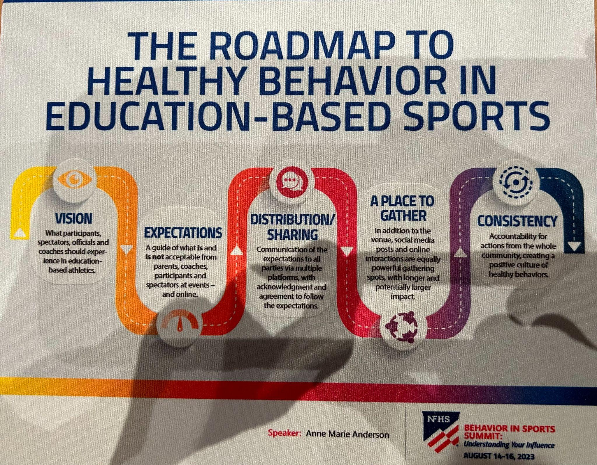

8/14/2023

- Review of Previous Officiating Consortium– Dana Pappas- Director of Officiating Services NFHS
  - Issue of Official retention and recruiting has been on going and got worse from the pandemic
  - 50,000 officials lost after covid
  - NFHS started a Official Consortium to help with recruitment and retention of Officials and the designed a playbook and best practice work book
  - NFHS has created a plan of Bench Bad behavior
  - The playbook was revised
  - The number is rebounding
  - Helped to 12,000 officials shortage
  - Officials perception of sportsmanship has worsen
  - We are here to be agent of Change
  - 80% of refs quit after two years because of Parent behavior
  - 70% of kids who quit sports by the age of 13 is because of their parents behavior
  - Officials are quitting faster than ones who sign up
- Concepts for Behaviors in Sports Summit: Understanding your Influence– Chris Boone NFHS Director of Publications and Communications
  - NIAAA will come up with a summit out of this conference
  - This is the largest advisory task force to promote challenges, identify best practice and give the NFHS a platform to move forward
  - We will learn from you and help facilitate change
- Keynote Speaker- Anne Marie Anderson
  - Roadmap to Healthy Behavior at Educational Based Athletics
  - 5 things that make a community
    - Passion
    - Vision
    - Content
    - A Place to Gather
    - Consistency
This is a School
  - Continuity- Covid disrupted this, Kids lost their community, They lost a place to gather and consistency.
  - Parents lost a place to sit and cheer on their kids.
  - Tramabonds- it was a shared experience during Covid
  - After Covid we did not know how to behave.
  - Post Pandemic Nickname –Panger- There is an uncertainty of what to do and a frustration of how to do it
  - Parents in Education based Athletics-
    - Emotionally Invested parents- They Paid money for Club or lessons and want their money back- Coaches and Officials hurt their investment
    - Parents of the athlete who did not play in High School or was cut and is trying to cure their athletic past
    - Super Athlete parent- All Star- Won Championships and their kids are a reflection of their success in sports- spoke about the kid with so much weight on his shoulders to be as successful as members of his family
    - Overinvested Parent is a killer of Joy of their student athletes
  - Social Media is not Helping- We did not have to deal with when we played- An Athlete's lowest point gets overplayed on Social Media Over and Over and people, parents, teammates and opponents get to comment on it. –Spoke about a paper who said in the paper a student athlete is academically Ineligible
  - How do we fix it
    - Community and see 5 things a community above
    - Come up with a vision and what do we want them to feel
    - How do we get the information out
    - Shut down negative on Social Media
    - A New York Conference if a Parent is asked to leave they must take their student athlete with them.
    - Cheer for positive plays
  - Spoke of a school of a coach who told a kid he would not make the team because of his fathers behavior.
  - Need all involved to partner to create a more positive culture
  - What is the number 1 thing that parents do that annoy you? Overwhelming answer was when parents yell at the refs- It is embarrassing and they are always wrong– All kids surveyed hate it
  - What do you enjoy the most about education based athletics- They said their teammates.
  - Most Athletes Athletic careers end when they graduate. 2% go on to play
  - Spoke about her Son who is autistic, ADHD and socially awkward and started to play water polo and that led to his best grades as he wanted to play water polo. Played Swim but not the same as water polo. His water polo coach called and said that he could not play and we need you on the team. He asked go to summer school. Mom made him work to pay for summer school to make him invested in his own education. He went and made $400 and cleaned trash cans after the garbage man came. He paid for summer school and got a B in Biology and he can play water polo. She asked the coach it is one kid, why did you care? I saw how happy he was last year. I wanted him to have his teammates again and if he did not have that his depression would get worse and I did not want him to be a statistic. I saw a kid that I could help and I wanted him to be a part of the team.

That is why we are not here for one kid, it is preparing them for life and positive experiences.

8/15/23

- First General Session- Working with Parents and other Fans to Promote Better Behaviors
  - Parents invest a lot of Money and time and travel.
  - 99.9% will not be Professionals
  - The goal is to build relationships and life long friends.
  - How do we get the message to the Parents that this is not a retainable financial return? It is education based Athletics and it is about having fun and learning life lessons.
  - Coaches let the parents act like that. There are too many coaches with egos.
  - Coaches need to step up and make it more about the coaches.
  - How do we get Parents to back off?
  - Coaches need to understand it is not about them.
  - Parents need help to adjust expectations
  - Need to define what educations athletics means to parents
  - Need to build relationships with youth organizations
  - Hold coaches accountable to high expectations of sportsmanship and teach students to the educational based athletics model
  - How do we deal with the parental pressure to try to get a coach fired for not winning because they feel they are teaching good sportsmanship instead of winning.
  - In survey the biggest issue are the parents overinvolvement and the coaches where winning is the only thing.
  - What are the solutions
    - How do we get to those parents?
    - Start with the Athletic Directors.
    - Sports meetings at beginning of the seasons- Sportsmanship
    - Set expectations of parents AD in big meeting and Coaches in team meeting
    - Parent Contract
    - Need a constituent Communication chain that needs to be followed by all
    - Question to the Executive Directors?
    - Is it possible to have state sanctions? Yes
    - State Association Directors will discuss some of this stuff at 2pm session
    - Need to go back to our school standards(Which We Have) and model behaviors. Time and investment is big to fix this
    - Social Media has driven some of the behavior of parents as well as peer driven- We have to undo a lot of issue that are serious problems
    - Constantly remind parents that “sports are fun” drive it home - push the healthy reasons for HS sports
    - How do we stop the empowerment of parents in club and youth sports and then have to give up the power when the kids get to High School.

- Second General Session- Considering all Shareholders in Social Media Sharing
  - Talking about positive stories on Social Media- Like what we already do(John Holt)
  - People only remember the bad stories. IE fight at a basketball game– That is a small % of what is written
  - The big stories tend to be not positive
  - How does the media Process if it is fair to a kid? We do look at the circumstance of the game and make sure that it shows positive sportsmanship. We don't post a technical foul, is it relevant and is it part of the story we are trying to tell? We will not put something in if it can be bulletin board material for either team.
  - Twitter has killed the game story and box score
  - We are in the Highlight Age. Parents are looking for videos to send to college coaches.
  - People on sidelines should have media credentials- Not allowing Parents.
  - What happens when something bad happens and is posted by someone who is not a credential person. When you see those videos is there something positive to come out of it? We always vet video and not blindly post. We will use it if it is newsworthy.
  - What can we do to filter and promote education based athletics? John Does that already for us. What they spoke about CIAC already does.
  - Need to report high school sports as a team not individual
  - Give out awards– Courage award- Again we do with the spirit of the game award
  - Schools are fined if a fan is ejected. Not sure what state
  - Social Media can be negative- We need to find a way to promote positive posts
  - How does the user want to brand themselves.
- First Breakout Session(2 Choices)
  - Adjusting Media Coverage from High School to College and Pro Sports (John)
    - Explores the different terms and phases that should be used in media coverage of high school sporting events and high school student-athletes in comparison to college and professional levels. As high school sports are thrust further into the spotlight with the rapid expansion of forms of media, using less critical language and maintaining a lower level of scrutiny are imperative to student-athlete well being.
1. What language is appropriate for coverage of high school sports? Celebrating the positive, framing the “negative” in gentler, more
constructive way, including in play-by-play broadcasting. Not including
name of officials in game story.
2. Stressing distinction of “education based” athletics vs. what is a
different focus in college and professional athletics.
3. State associations send media a document of guidelines and
expectations. Media must sign and acknowledge receipt of this
document in order to receive credentials. New Mexico Activities
Association uses such a document.
4. State associations should work collaboratively with state media
including being available with comment and explanation when
respectfully requested by media outlets.
.
  - A Team Approach to Influencing Sports Behavior (Steve and Hildie)
    - Empowers administration to establish and maintain control over their athletic facilities during events. Inviting firm behavior, policies, developing detailed plans for communication and emergency situations and handling difficult conversations with supporters are among topics to be discussed.
      - Team approach (not just the AD) - need AD, Admin, staff/volunteers, and coaches all working and taking responsibility
      - Coaches - should have the most responsibility and set the culture for proper behavior in their sport. AD’s hold coaches accountable for this.
      - Every job description for a coach should outline a sportsmanship component.
      - Every interview should include a sportsmanship question, and how a coach plans to set the tone.
      - Five levels of influence
        - Coaches
        - Participants
        - Parents
        - Student body
          - Identity students leaders
          - Create relationships with your students
        - Officiating crew
          - Require officials to read a sportsmanship statement to the team/captains before games
      - ***note from safe school** need /have a admin at every event to start the influence on the 5 levels
      - 4 Roles of inappropriate sports behavior
        - Instigator
        - Accomplice
        - Bystander
        - Unstander - Needed on the Team
          - Cheer squad
          - Parents groups - PTO/Boosters
          - Student leaders
          - Fan section leaders
        - 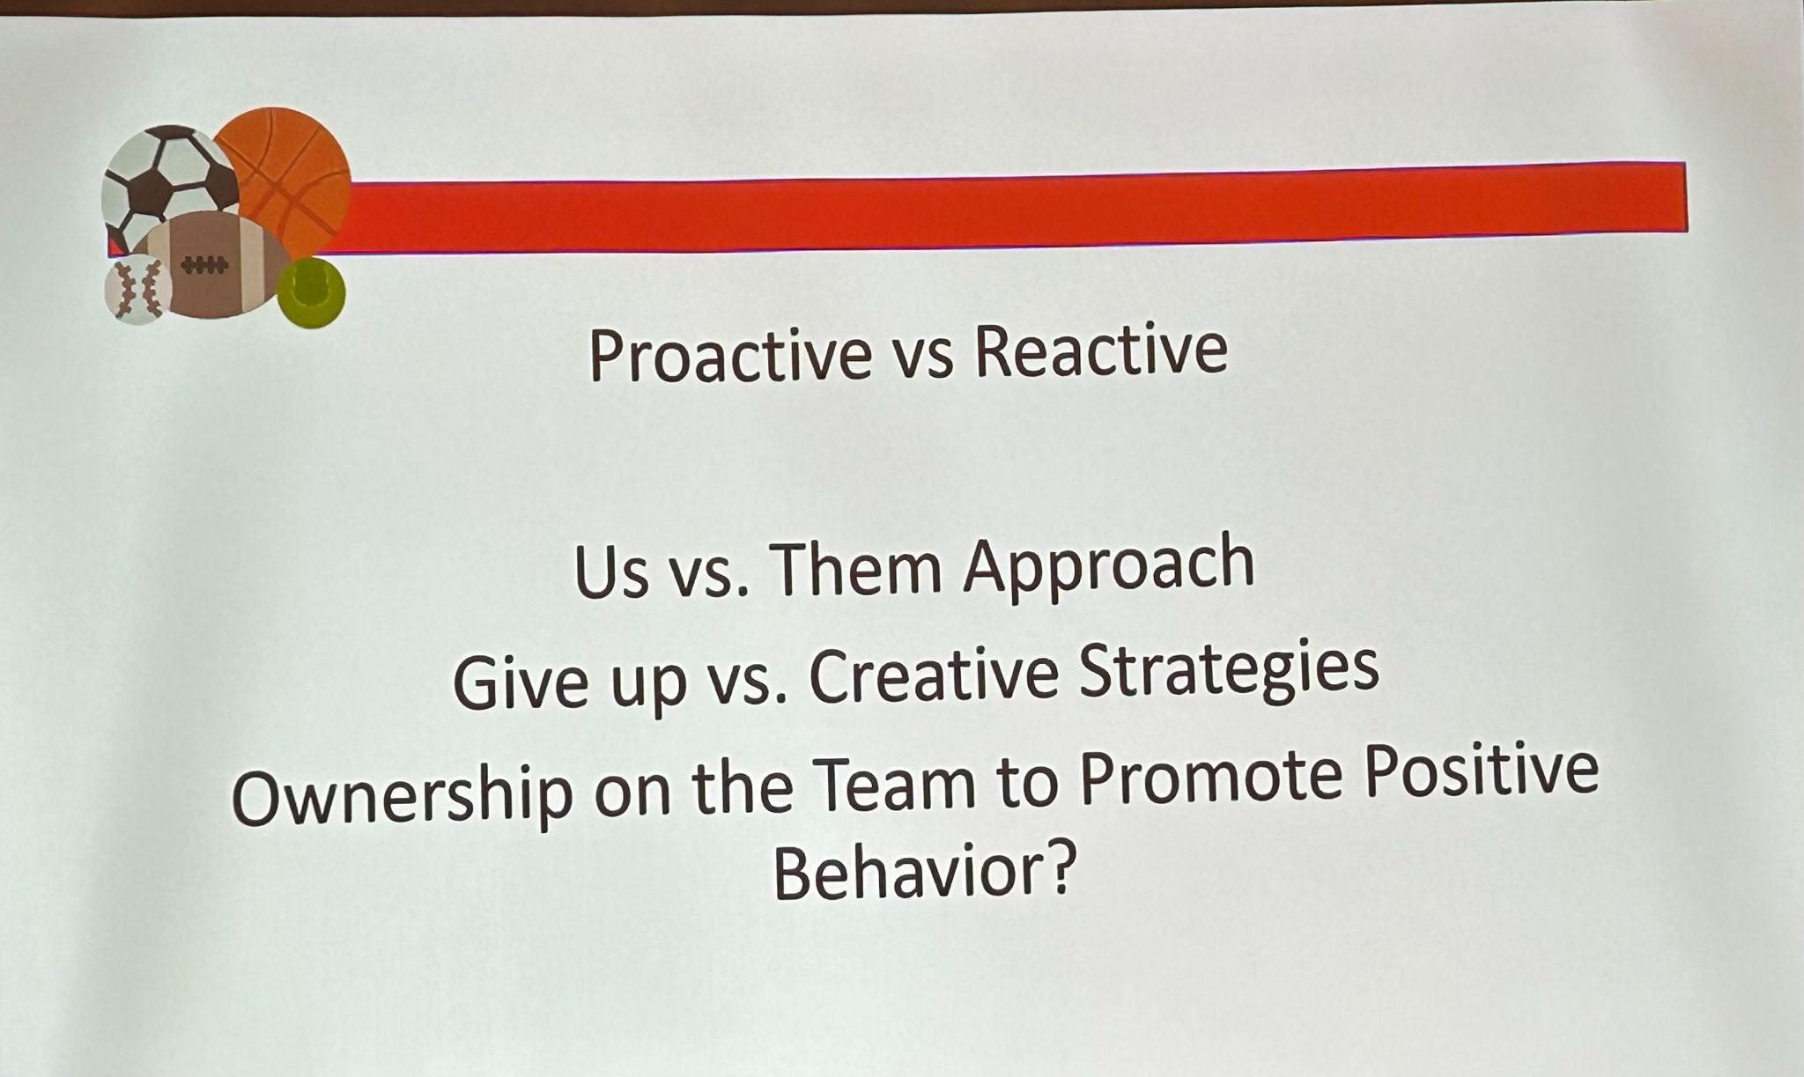
        - Strategies with Parents Who have crossed the line-try to refocus them. Walk toward them
          - Timing of the confrontation
          - Appointment
          - Apologize
          - Document
          - Meeting Room Arrangement
          - Their Expectation
          - Meeting Conclusion
        - 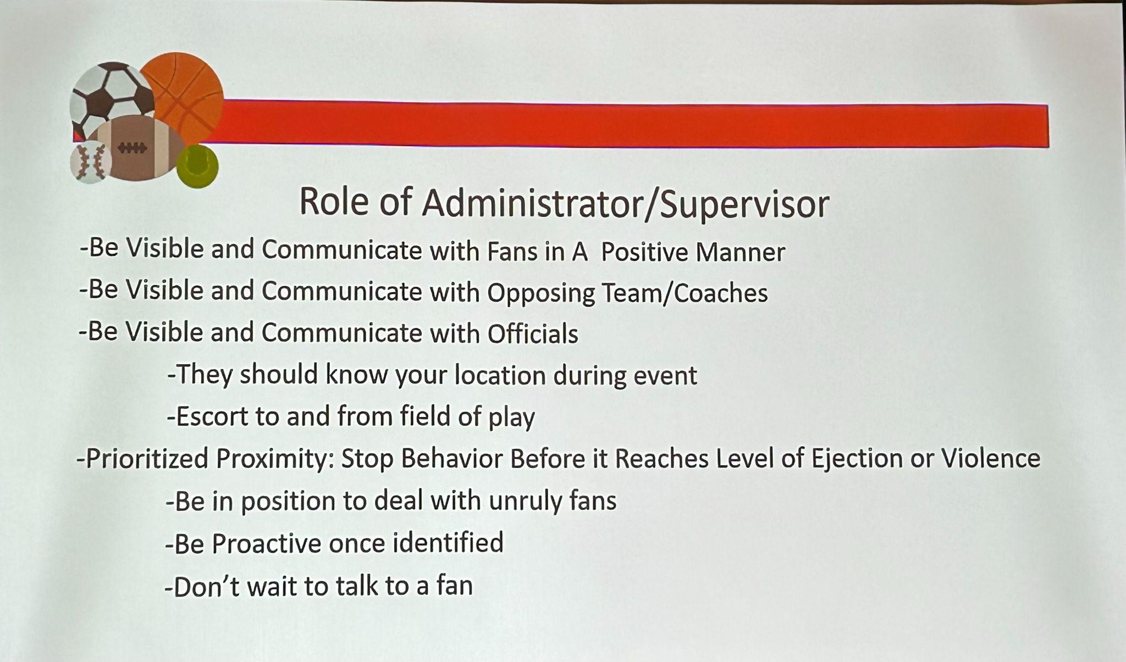
        - 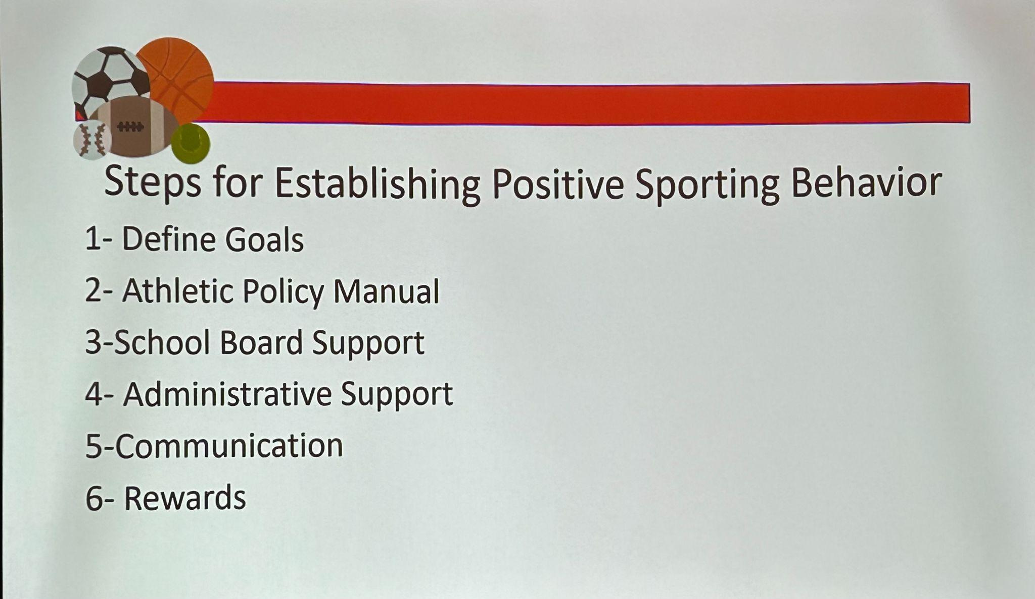
        - Give rewards as we do with Micheals cup-Should Give Banners for the gym
        - Give parents rewards- If they take the NFHS Sportsmanship class by NFHS for parents they get swag or free tickets after they hand in the certificate.

- Third General Session- Laying the foundation for Good behavior-Invest in your Middle School
  - How important are pre-season meetings at the middle school? Not many people do it. – It is important to do as it is their first time in Education Based Athletics. How many Middle Schools in CT do it.
  - Illinois sends everything to their middle schools that is sent to their high schools.
  - Some states treat Middle School the same what as High Schools–
  - The first communication we should have should be positive and not because of an issue–
  - Having them follow eligibility rules and learning expectations and the kids and parents learn the rules at a younger age.
  - Administrators need to be seen at games
  - Schools getting fined for bad fan behavior- Tennessee
  - Parent Ejected and must take the NFHS Sportsmanship Course before they can go to another game
  - Player Ejected- 2 games and take NFHS Sportsmanship Course before they can return
  - Coaches 2 game suspension and take NFHS Sportsmanship Course before they can return and $100 fine. 2nd time 5 games and $250

- Forth General Session- State Associations Best Practice
  - Showed a Vermont Principals Association Video(Very Good)- https://vpaonline.org/
  - Ohio– Has a Variety of things that we have done, now we need to change the delivery. Many of the AD are leaving and Young kids are coming in who some have never even taught. We need to help them deal with parents and issues. We are creating buckets(Are posted on their website) officials, student sections, fans, parents- We are going to do a better job of sharing.They are training their coaches on Athletes Mental Wellness, The Principal is in charge of events, Schools need to have people working at games. We need to put a bigger focus on middle school.
  - Response to Intervention in Vermont, Statement by kids before the games, Tier 1 intervention, Tier 2 intervention, Tier 3 Support– See Vermont Page she spoke very quick, Spoke about pausing the game to stop issues.
  - California- We are trying to figure out how to enforce the rules, We changed our mission statement”All students should be able to Belong and Compete. Everything is tied to our Mission. Take best practices and share. Better when kids say announcements at the beginning of the game.
  - Colorado- Faced Official Shortage and that was a strategic improvement this year, Sportsmanship and sporting behavior is what we have really discussed in the spring and need to improve next school year. We need to define and model what a good sporting event with great sportsmanship and what it looks like. Need to find support for game personnel. Do we set up an environment of good athletic directors. Need to educate game personnel. Who is the accountable adult at evey game that is responsible for positive sportsmanship. Create an environment that is inclusive for all students. How do we teach the student body?

- NFHS
  - Know your role - Parents, Students, Coaches, Officials
  - Golden Role
  - 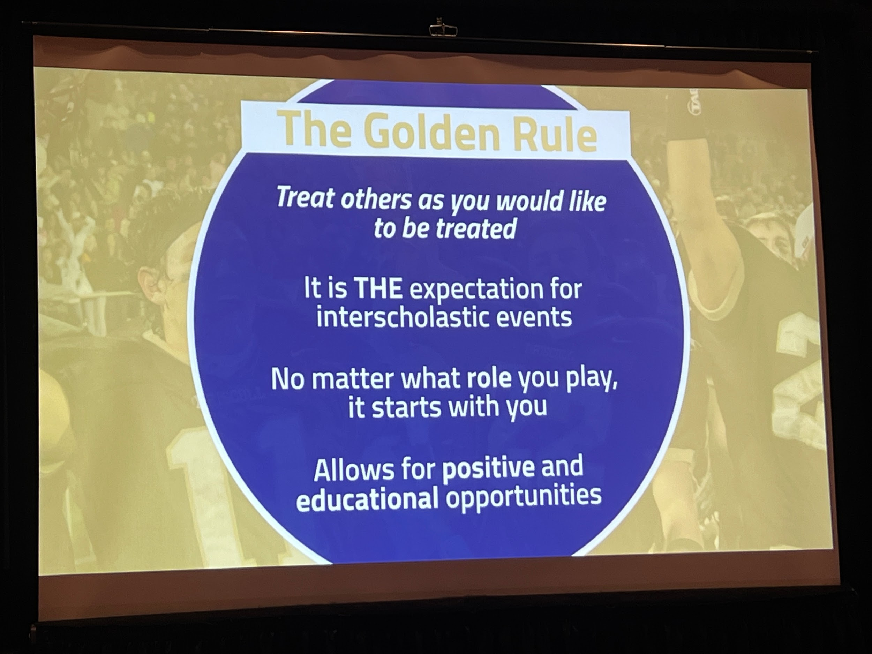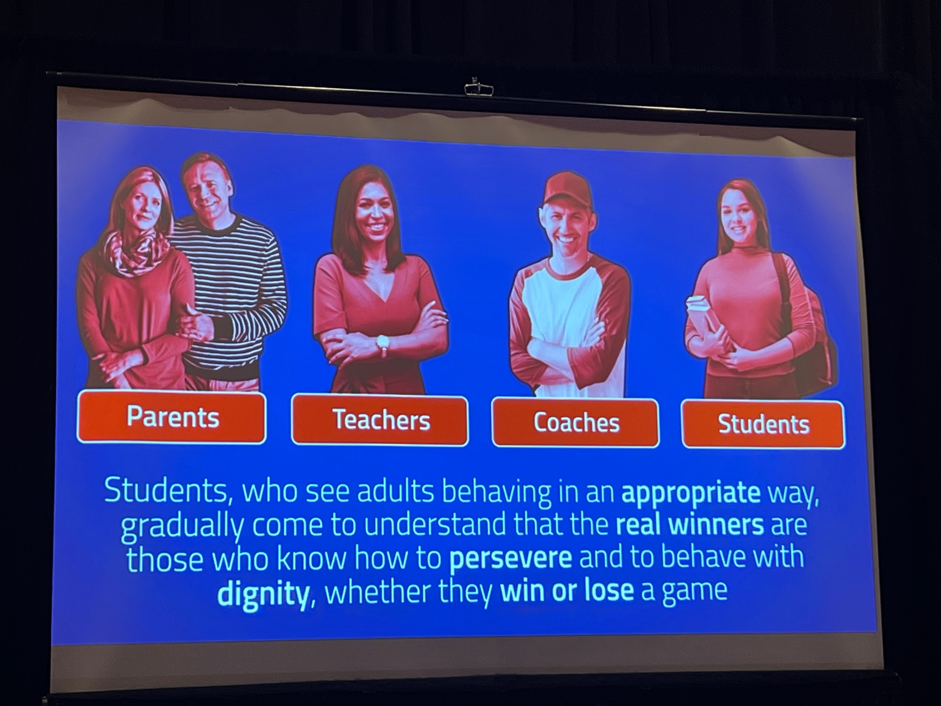
  - https://nfhslearn.com/courses/the-parent-seat
  - https://nfhslearn.com/courses/positive-sport-parenting
  - https://nfhslearn.com/courses/sportsmanship-2

- Second Breakout Session (2 Choices)
  - Balancing Sportsmanship and Success(Steve is on the presenting Panel)
    - A discussion of how coaches can manage two of their biggest priorities as team leaders; producing winning results and developing respectful competitors. Panelists will share strategies for navigating the pressure of internal drive to win without sacrificing sportsmanship standards within their programs
      - Steve - discussed packet - Class Act and athletic advisory/council
      - Monica (state office) Oregon -
        - STAR (be a star school) - https://www.osaa.org/docs/equity/S.T.A.R.%20Sportsmanship%20Expectations.pdf
          - All we expect is that you let each of us perform in an environment of SAFETY, TOLERANCE, ACCEPTANCE and RESPECT. We call it being a STAR.
        - Teaching how to cheer for your team, not against the opponent
        - Training - Ask about this
      - Meagan - Wrote book “The team adult play book”
        - Spoke as a parents and what she had witnessed
        - Breakfast meeting - read books and discuss and put roots on the ground to establish standard for good sportsmanship
        - What is a standard of behavior? Why allowed in one setting and not another?
  - Managing your Expectations Event Security(Jay Hammes) Steve had him at his school and can report on this- Jay did a report for him.
    - Our Country is experiencing an all time high of negative behavior at competitive after school events. Most problems in middle and high school contests are preventable if the host school practices proactive game management. Administrators can get out in front of things before they spin out of control. This session will explain the”Make Sure” techniques for providing a safe environment, including de escalation skills.

8/16/16

- Not Just for Clicks: positive storytelling in High School sports(John Holt Presented)
  - While altercations and acts of poor sportsmanship often make the headlines, this session is designed to encourage media to celebrate the positive, uplifting stories produced through educational based high school sports. A great starting point for finding these stories, from the media’s perspective, could be to establish relationships with local athletic directors.
- Modeling Behavior from the Sidelines- working with Officials.
  - Exploring how the words, actions and temperament of coaches and administrators can directly impact the behavior of spectators at events. As two of the most influential figures in any high school athletic venue, coaches and administrators set the tone for their supporters - positively or negatively - in the way they interact with game officials, as well as opposing coaches, players and fans.
    - The most sporting/appropriate way a official should stand is with their hands behind their backs.
      - Arms crossed in front of the chest or at the stop position shows defensiveness.
      - Arms behind back shows you are listening and open to hear what the coach is saying.
    - Coaches need to be consistent with all coaches/venues.
      - Important for coaches to have a pre-game discussion with officials and the expectations.
    - As a coach on the sideline and fans are watching how you respond and handle it, that's how they will handle it. Coaches need to keep their cool, which will help keep the spectators cool (most of the time)...it at least sets a standard.
    - Need to teach and how coaches accountable on keeping it professional and keeping their cool
    - Get coaches to officiate in their off season.
      - Offer bonus or reward (CEU’s - since they have to take the course)
      - Help with shortage and helps coaches understand the other side
      - Get HS athletes to officiate at the elementary or middle school level. - maybe as volunteers (community service project for a team)
      - Scenario 1
      - 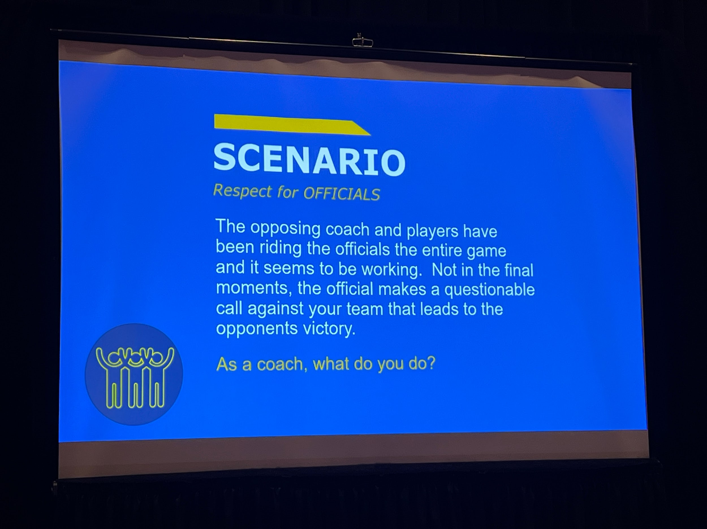
      - Scenario 2
        - 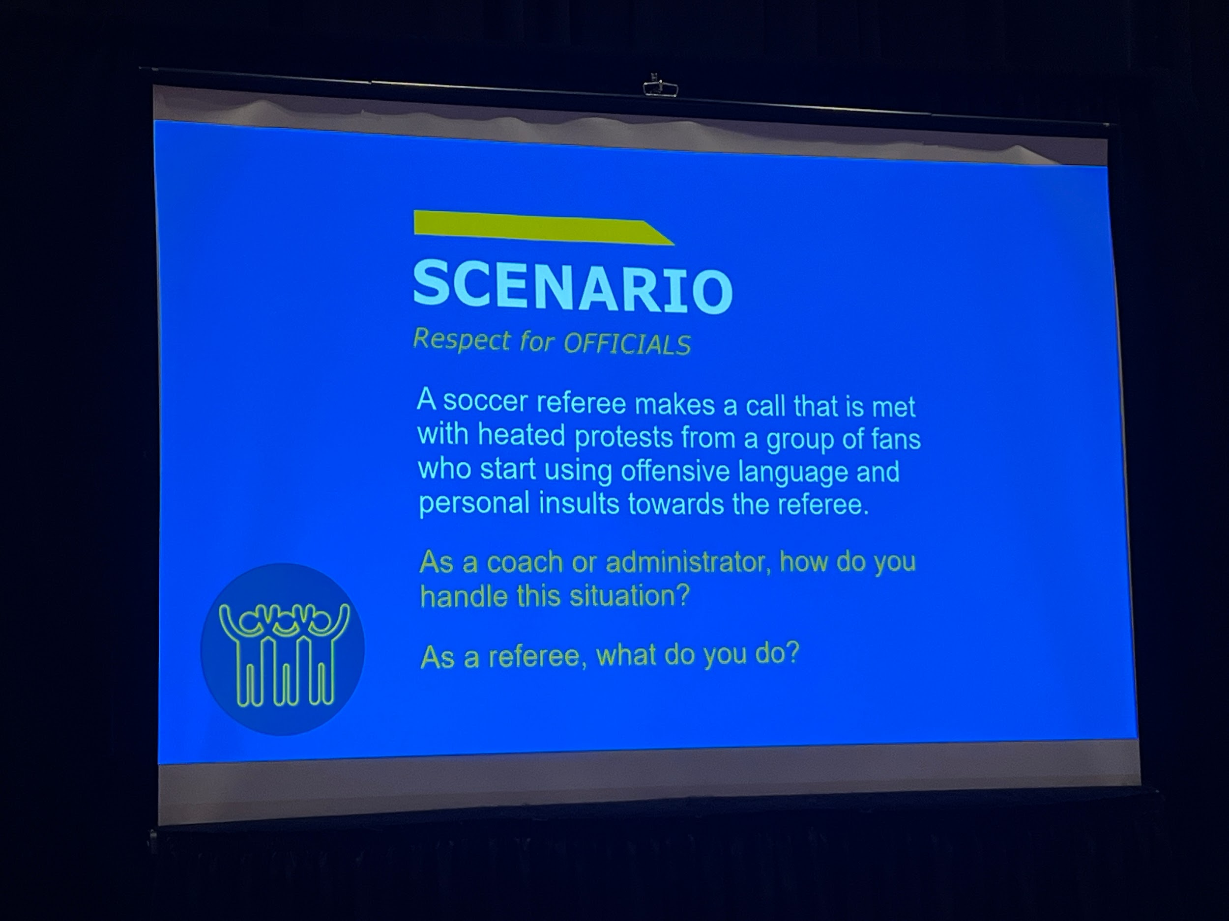
        - Admin/site supervisor address the parent, possible ejection.
        - Officials should not address the parents..have admin do so, if one if not there stop the game and have the coach address it.
        - It is our responsibility to protect the officials.
      - What are some key strategies that you’ve seen or used to build more positive relationships with officials.
        - Befriend them..get to know your officials
        - Thanks them for being there..extend appreciation
        - Having a student-athlete or student leader greet officials
        - Have pre-season meeting with coaches and officials and get to know them and discuss how the season will go and expectations

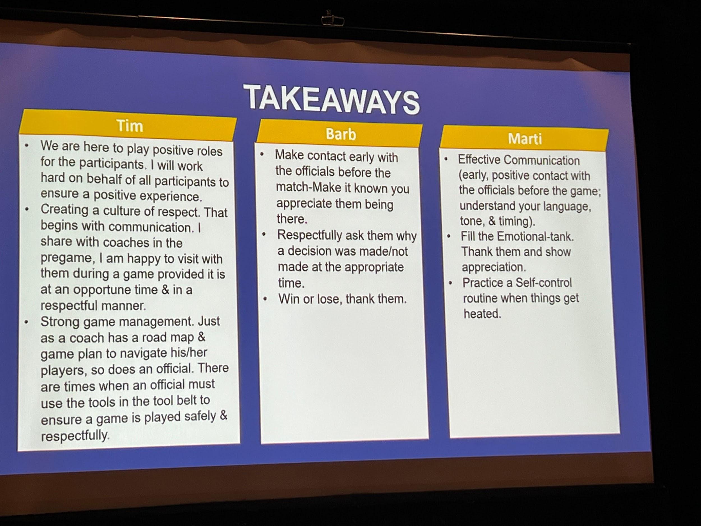
Fifth General Session Mental Health:Parent Triggers and Student Impact
- Review of where we are now(Insert Here)
- Know Thyself-
- Identify Sports, Parents and personalities
  - 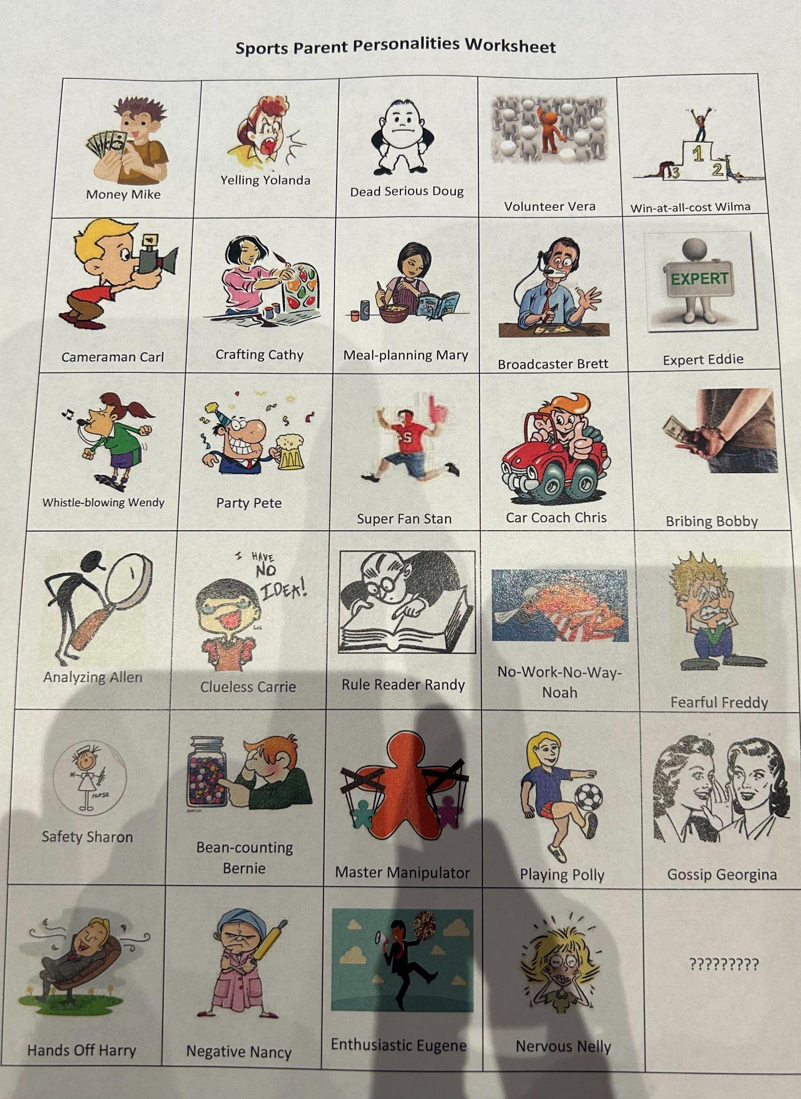
  - What are the 3 most Toxic Personalities above
  - Video “Daddy pushes goalkeeper son to make epic save”https://www.youtube.com/watch?v=NbOz7d4Azr0
    - Discussion on it
    - Why did he do that? He wanted his son to pay attention, do well, he is an extension of him, worried what it would look like to his peers.
  - Negative Emotions-Can escalate to toxic behaviors
    - Need to teach people on triggers to stop negative emotions
  - 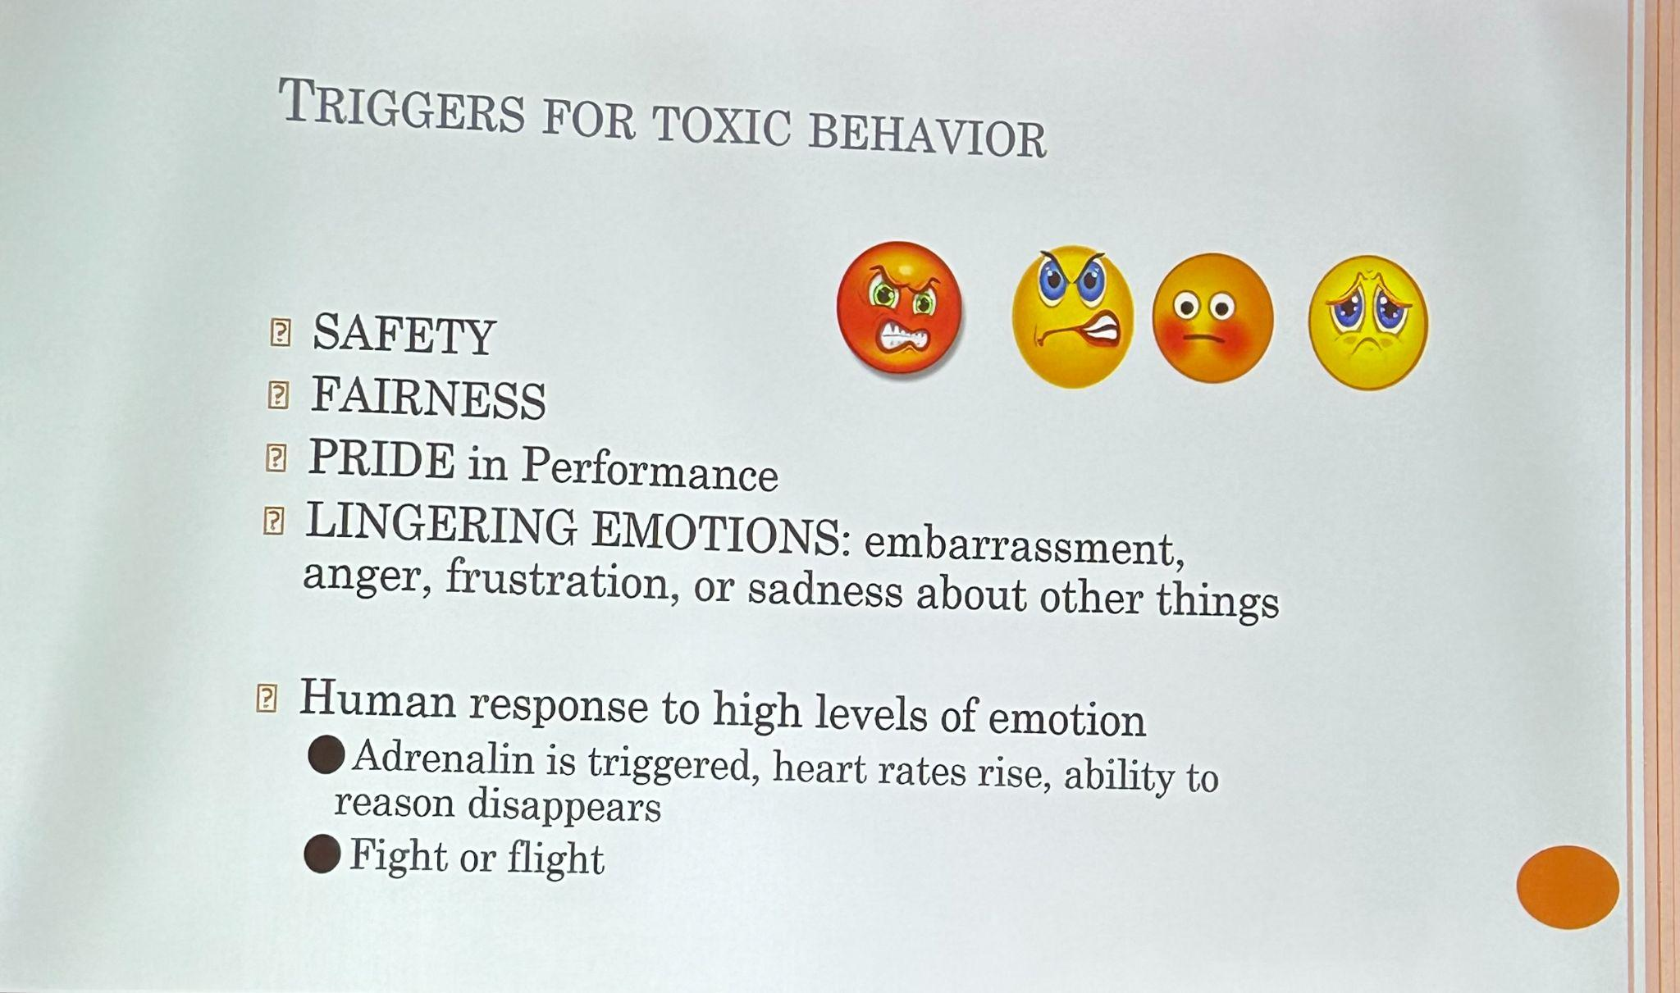
  - Need to get skilled at Difficult Conversation
  - Learn about Restorative Council
  - 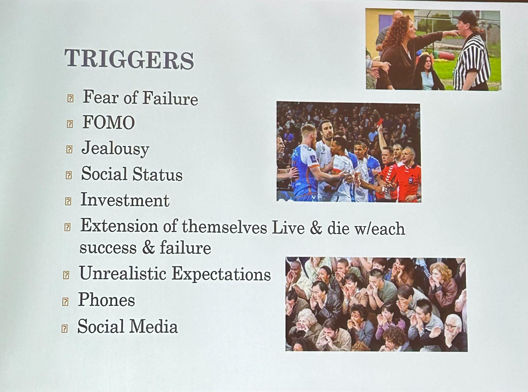
  - Sport Parent Video-Frank Martin basketball Coach
    - https://www.youtube.com/watch?v=fc5BfCCFzQI
  - 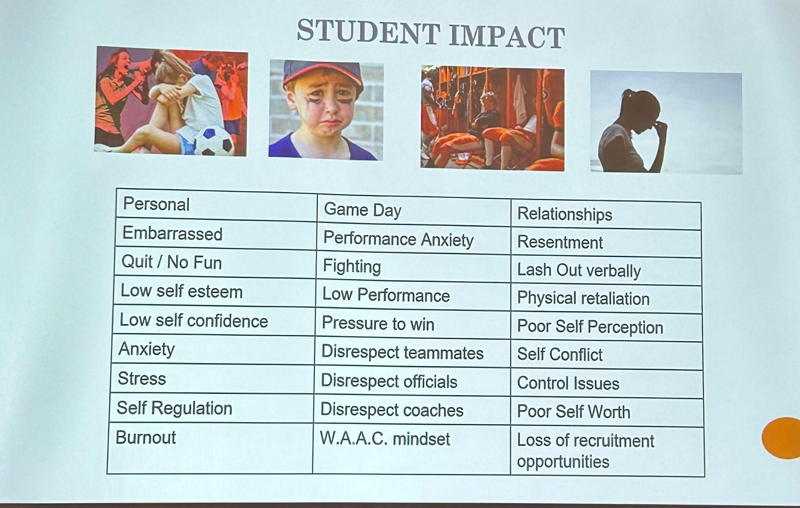
  - Sports Should make kids feel great about themselves
  - 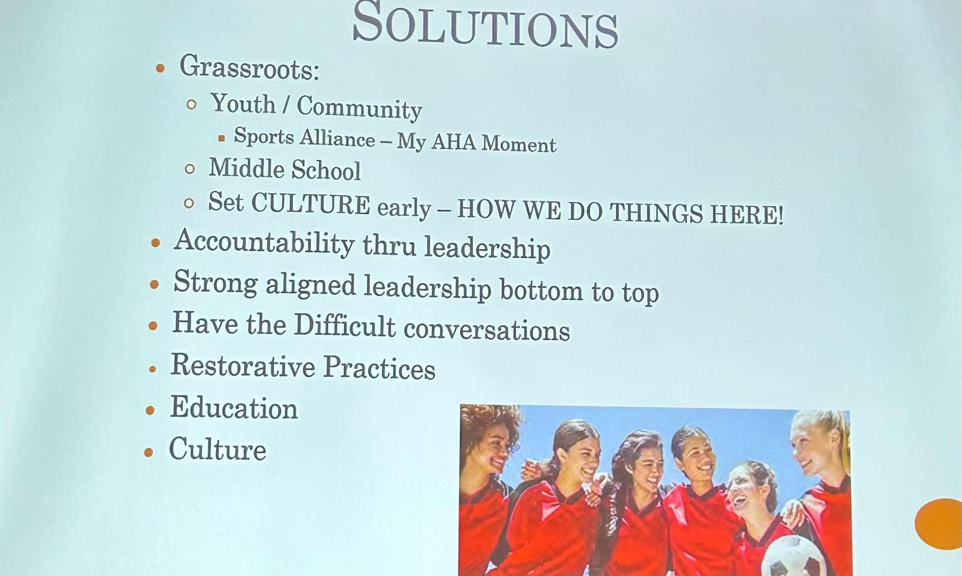
  - When it Become Toxic there are three choices
    - Wither
    - Withstand
    - Become a Change Agent

National Officiating Perspective
- They are collecting Data to help drive change
- 35,800 responses to survey
- Not publicly available now
- Will be available on NASO website
- A Lot of the data is negative, but we will take the negative and turn into positive
- 12% of Sports Official were physically assaulted and this is unacceptable– Positive that states have laws on this topic
- We never has so much attention on recruiting sports officials
- Officials need to be in a safer environment and supported
- 50% of officials felt unsafe
- 68% say sportsmanship is worse than ever
- There is more awareness now
- More money is being spend on Officials
- There is more investment in Officiation by NFHS
- The next obstacle is retention of officials
- We(Officials) are part of the problem we need to enforce the rules- If we(officials) are doing our job we will be helping officials

Next Steps in NFHS Officiating Serves Department
- Officials are almost forgotten until there is not enough
- We need to recognize, respect and support them
- They are the 3rd team on the field without anyone cheering them
- Without them no games dont take place
- They elect to do something that 50% of the people will not like them
- They do it for your kids and your community
- Social Media Initiative to Highlight Officials.
- NFHS will support all 51 state official association
- Work does not end today it is just a beginning

Karissa Closing Remarks
- Thanks all for being here and being engaged and open to sharing and learning
- Next Steps
- Strategic plan and Priorities
  - https://www.nfhs.org/media/5989185/2021-2025-nfhs-strategic-plan.pdf
- We are committed to the work like this Behavior in Sports SUmmit
- The importance of Community and Collaboration and this is how we make success
- NIAAA, PCA, Parents, Schools, State Associations, Media- we all need to work together
- We need to have Media Help
- Work with Youth Sport Agencies
- Task Force
  - What will the standards Be to move forward
  - Resources
  - What are best practice
  - We are committed that is why we are here this week
  - Bring the leaders of Youth sports together
  - Place kids on Panels to speak to leaders of youth sports to discuss issues
  - Let's Listen to the kids
  - If you are task force oriented we would like to have you help
  - We have the opportunity to leave a legacy

