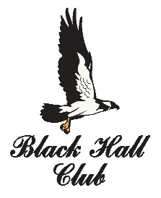 June 1, 2018

Congratulations!
Through nothing less than hard work and determination, you have qualified for the CIAC Open Golf Championship! This inaugural tournament will take place on June 9th, 2018 and will crown the first ever Boys & Girls Connecticut High School Open Champions. As proud host to this special event, we here at the Black Hall Club hope to provide you with a very memorable day.
The Championship round will be a 1:00pm shotgun start. Immediately following tournament play, we would like to invite you, your family members and coaches to a barbeque in honor of all tournament participants. The first Open Champions will be announced at an awards ceremony that afternoon.
Prior to championship day, we welcome you to come play a practice round here at the Black Hall Club. Please give us a call to schedule your round and feel free to invite a friend or family member to play along with you. The number to the golf shop is (860) 434-2038.
We look forward to welcoming you to Black Hall on June 9th! If you have any questions or concerns, please contact us at any time.
Please contact Gregg Simon at the CIAC office at gsimon@casciac.org to confirm your attendance by the end of the day on Friday, June 1.

Chris Gearing Bill McNamara Andrew Campbell
President Golf Chairman PGA Professional

Black Hall Club
49 Buttonball Road, Old Lyme, CT 06371
www.blackhallclub.com
860-434-2038

