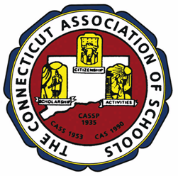

June 15, 2009

Dear Colleagues,
The CAS Elementary Level Board of Control has created a survey to ascertain the degree to which member school principals, assistant principals, teacher leaders and central office administrators value each of the elementary level services provided by CAS. The resulting data will help us to better serve you in the future. The fifty-five item survey covering elementary level student services, professional development, advocacy, recognition programs and other services, will take between four and six minutes to complete. Please click on the link. We value your input!
You can access the Elementary Survey by going to: http://www.casciac.org/elsurvey.shtml

Best Regards,
Regina S. Birdsell
Assistant Executive Director for Elementary Level

