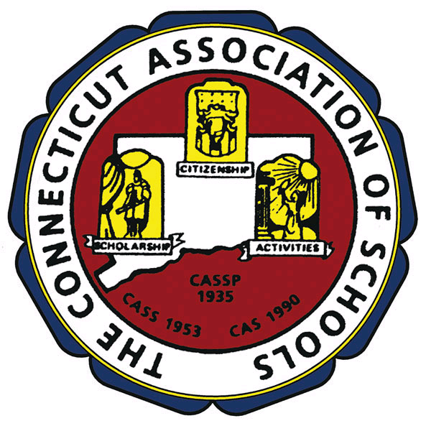

THE CONNECTICUT ASSOCIATION OF SCHOOLS

14P^{THP} ANNUAL
ELEMENTARY SCHOOL PROGRAM
RECOGNITION BANQUET

NOVEMBER 27, 2007

AT THE AQUA TURF CLUB
IN SOUTHINGTON

AT 6:00 P.M.

REGISTER ON-LINE AT
www.casciac.org/register

