IMPORTANT – PLEASE READ AT ONCE

PASSES ACCEPTED FOR 2021-2022
WE DON’T ACCEPT Connecticut High Sch Coaches Assoc Cards at CIAC Tourn!!!

- THE PRINCIPAL ARE TO BE ADMITTED FREE
- GOLD PASSES-PRESS CARDS
- CIAC OFFICIALS MEMBERSHIP DIGITAL ECARD
(Only for the sport they officiate)

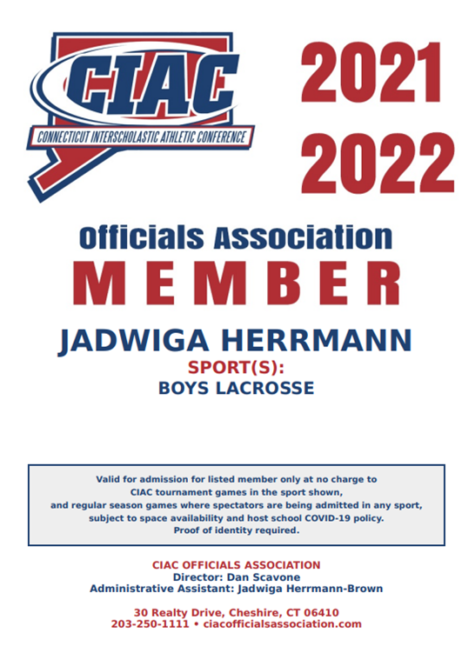

Any questions please call (203) 250-1111

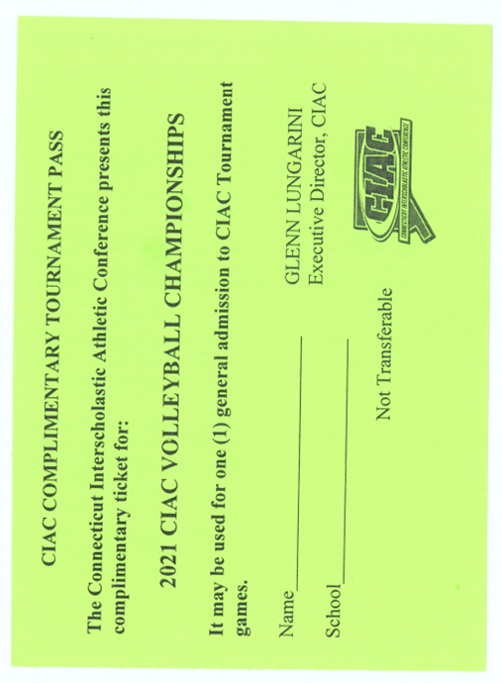
- GREEN PASSES WILL HAVE THE “SPORT OR SEASON NAME” ON THEM WHICH ALLOWS THE PERSON ENTRANCE TO ONLY THAT SPORT (EXAMPLE BASEBALL) OR SEASON (EXAMPLE FALL). THIS PASS IS NOT TO BE ACCEPTED FOR ANY OTHER SPORT OR SEASON.

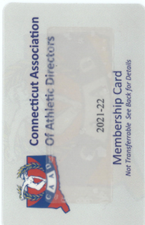

- ATHLETIC DIRECTORS MEMBERSHIP CARD

Check for correct YEAR 2021-22

Any questions please call (203) 250-1111

