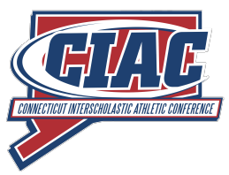
MEDIA GUIDELINES FOR CIAC HOCKEY STATE SEMIFINALS AND FINALS
1) Media credentials are to be visible at all times.
2) Press box seating will be open for the semifinals, but there may be assigned seating for the finals.
3) All postgame interviews for the opening games each night of the semifinals will be conducted downstairs outside team locker rooms. Access is down the stairwell located behind the press box. Short head coach and players interviews with the winning team for the second game of each semifinal, as well as all three finals, may be conducted at ice level from the bench area. This is done to help those on deadline, particularly local TV affiliates. All other interviews should take place outside the locker rooms.
4) Photographers and videographers can film along the concourse, through the glass at rink level on the lobby side of the building, and in handicapped seating areas, if unoccupied.
5) Photographers and videographers interested in filming the championship postgame awards ceremony from ice level should connect with John Holt. There is limited access to the home bench in the postgame and media will be escorted through the locker room to the bench. Media is at no time allowed on the ice surface.
6) No live streaming of the games is permitted (Facebook or other platforms). The NFHS Network holds exclusive streaming rights.
7) If you will be covering 2024 championship games beyond tonight please keep your CIAC media pass for those games.
If you have any questions please call or text CIAC Media Director John Holt at (508) 740-4738

