Rigorous Exam Checklist and Item Analysis (revised 12/2014)

Exams in every content area should be rigorous and should provide students with opportunities to apply learning, problem-solve, and support higher-order thinking.

Prior to administering the exam please complete the first 4 columns of the table with the item number, the standard/skill it assesses, its DOK level, and the possible points or scoring criteria. This table needs to be turned in to your department's Curriculum Assistant and to administration.

Post-exam you can use the last column to do an item analysis.

Question/  Item Number | Standard/Skill | DOK Level 1- 4 | Scoring Criteria/ Possible Points | Item Analysis
1a | F.BF.1a, F.BF.2, F.IF.3, F.LE.1b | 1 | 5 pts -  1 pt for type  1 pt for lin/curve  3 pts terms
1b | F.BF.1a, F.BF.2, F.IF.3, F.LE.1b | 1 | 5 pts -  1 pt for type  1 pt for lin/curve  3 pts terms
2a | F.BF.2, F.IF.3, F.LE.2, F.LE.1c | 2 | 3 pts -  1 pt for U₀  2 pts u_{n}
2b | F.BF.2, F.IF.3, F.LE.2, F.LE.1c | 2 | 2 pts
2c | F.BF.2, F.IF.3, F.LE.2, A.REI.3 | 2 | 2 pts
3a | F.LE.1a, F.LE.1c | 2 | 5 pts
3b | F.LE.1a, F.LE.1c | 2 | 5 pts
4a | S.ID.1, S.ID.2, S.ID.3 | 1 | 5 pts
4b | S.ID.1, S.ID.2, S.ID.3 | 1 | 2 pts
4c | S.ID.1, S.ID.2, S.ID.3 | 1 | 5 pts
4d | S.ID.1, S.ID.2, S.ID.3 | 1 | 2 pts
4e | S.ID.1, S.ID.2, S.ID.3 | 2 | 3 pts
5a | S.ID.1, S.ID.2, S.ID.3 | 1 | 4 pts - 2 for mean, 2 for sd
5b | S.ID.1, S.ID.2, S.ID.3 | 2 | 3 pts
5c | S.ID.1, S.ID.2, S.ID.3 | 1 | 5 pts
5d | S.ID.1, S.ID.2, S.ID.3 | 2 | 5 pts
6a | A.CED.3, A.CED.4, A.REI.5, A.REI.6 | 2 | 5 pts
6b | A.CED.3, A.CED.4, A.REI.5, A.REI.6 | 2 | 5 pts
7a | F.BF.1, F.BF.2, F.IF.3 | 1 | 3 pts
7b | F.BF.1, F.BF.2, F.IF.3, A.CED.1 | 1 | 3 pts
7c | F.BF.1, F.BF.2, F.IF.3 | 1 | 2 pts
7d | F.BF.1, F.BF.2, F.IF.3 | 1 | 3 pts
8a | F.IF.1, F.IF.2, A.REI.10 | 1 | 2 pts
8b | F.IF.1, F.IF.2, A.REI.10 | 1 | 2 pts
8c | F.IF.1, F.IF.2, A.REI.10, N.Q.2 | 1 | 4 pts - 2 pts domain, 2 pts range
9a | F.IF.7b, F.BF.3 | 2 | 5 pts
9b | F.IF.7b, F.BF.3 | 2 | 5 pts
9c | F.IF.7b, F.BF.3, A.SSE.1b | 2 | 5 pts
10a | A.SSE.1a, A.REI.11, A.REI.12 | 2 | 10 pts
10b | A.SSE.1a, A.REI.12 | 2 | 5 pts
Performance Task | Various, mostly S.ID and F.IF | 3 | 60 pts total: 5 points for each part or question

Please add additional lines to the table as needed.
Remember:
o All exams should give students the opportunity look at problems or concepts analytically and allow them to apply what they should already know from taught coursework.
o Students should have the opportunity to develop, clarify, draw inferences and generate possible conclusions or solutions to problems or situations.
o For science teachers of freshman and sophomores only: Essay CAPT-like responses must be included for freshmen and sophomores.
o While exams may contain some recall knowledge that should not be the major part of any major examination. A well constructed exam should contain or give the students the opportunity to demonstrate their higher order thinking skills by giving them the opportunity to demonstrate comprehension, apply knowledge, analyze, synthesize, evaluate and create.

Academic Algebra II

Midterm Exam – 2014-2015

Name __________________________

Date ___________________________

Final Grade: __________

Answer each question and show all work.

- State whether each recursive formula defines a sequence that is arithmetic, geometric, shifted geometric, or none of these. State whether the graph of the sequence would be linear or curved. Then list the first five terms of the sequence. (F.BF.1a, F.BF.2, F.IF.3, F.LE.1b) (DOK 1)

a. u₀ = 16 b. t₀ = -7
u_{n} = (1 + 0.25) u_{n-1} where n > 1 t_{n} = u_{n-1} + 3.5 where n > 1

2. Ted just bought a new car for $22,500. Suppose the value of the car decreases by 15%
each year. (F.IF.3, F.BF.2, F.LE.2, F.LE.1c) (DOK 2)

a. Write a recursive formula for calculating the value of the car after n years.

b. What will be the value of the car after 5 years?

c. After how many years will the car be worth less than $5000? (A.REI.3)

3. Lana is recovering from surgery. She takes a pill containing 250 mg of pain medication
every 6 hours. After 6 hours, 40% of the medicine remains in her body.
(F.LE.1a, F.LE.1c)
a. How much medicine will be in her body 24 hours after she takes the first pill?

b. How much medicine will be in her body in the long run?
4. This table show the population in 2005 for the 16 counties in Maine.
(S.ID.1, S.ID.2, S.ID.3)(Part c is DOK 2, else is DOK 1)
a. Find the five number summary for the data.

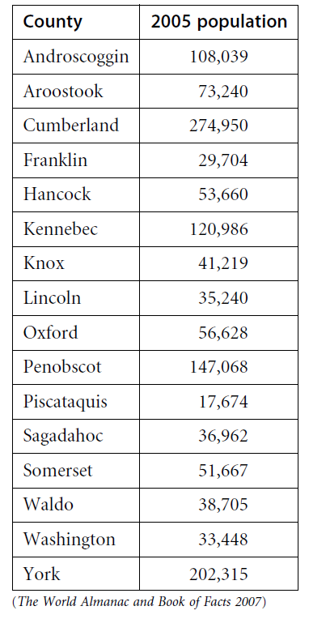

b. Find the range and the interquartile range.

c. Create a box plot of the data.

d. Are the data skewed left, skewed right, or
symmetric?

e. Do the data include any outliers
(values that are more than 1.5 $∙$ IQR from
either end of the box)? If so, which counties have populations that are outliers? (DOK 2)

5. Use the data from Problem #4
(S.ID.1, S.ID.2, S.ID.3)(DOK 1)
a. Find the mean and standard deviation.

b. Which counties have populations that are more than one standard deviation
above or below the mean? (DOK 2)

c. What is the percentile rank of Kennebec County? (DOK 1)

d. Make a histogram of the data using an appropriate bin width. (DOK 2)

(A.CED.3, A.CED.4, A.REI.5)
6. Use an appropriate method to solve each system of equations. (DOK 23)

a. y = ¼ x + 10 b. -4x - 3y = -7
3x - 2y = 0 6x + 2y = -17

7. Consider the arithmetic sequence: 6, 3, 0, -3, -6, -9, ...
(A.CED.1, F.BF.1, F.BF.2, F.IF.3)(DOK 1)
a. Write a recursive formula that describes this sequence. Use u₀ for the starting
term.

b. Write an explicit formula for this sequence.

c. Determine the value of u₂₇.

d. Write an equation (in x and y) for this sequence.

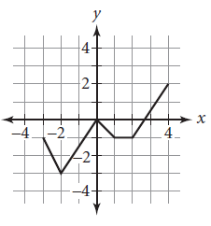

8. The graph of y = f(x) is shown here.
(F.IF.1, F.IF.2, F.IF.5, A.REI.10, N.Q.2)(DOK 1)
a. Find f(-2)

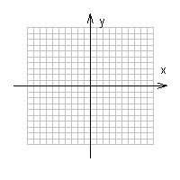
b. Find all x for which f(x) = -1

c. What are the domain and range of f?

9. Each graph is a transformation of the graph y = x², y = |x|, or x² + y² = 1. Write an
equation for each graph. (F.IF.7b, F.BF.3, A.SSE.1b)(DOK 2)

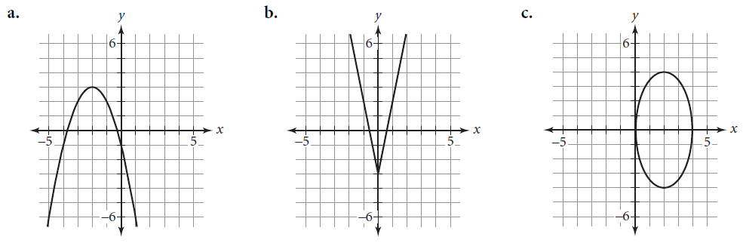

10. Consider this system of inequalities.
(A.SSE.1a, A.REI.11, A.REI.12)(DOK 2)
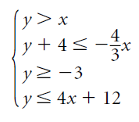

a. Graph the feasible region and find
the coordinates of its vertices.

b. Find the point in the feasible region
that maximizes the value of -2x - 3y.

