CONFERENCE COMMITTEE
Vaughn Ramseur, Chair
Roosevelt Middle School
Barbara Ripa
Ellington Middle School

Joyce St. Germaine
King Philip Middle School
Rochelle Schwartz
Northest Middle School

Meg Shea
Roosevelt Middle School
Tory Savage
Thomaston

Earle Bidwell
Assistant Executive Director

Connecticut Association of Schools
203-250-1111

Janice Grecco
Administrative Assistant
Connecticut Association of Schools

University of Hartford’s
Art School

200 Bloomfield

West Hartford

Door to Door Directions
Can be found on out website: www.casciac.org
Click on the gray box labeled “Get Directions” under our logo, then scroll down to find University of Hartford under Banquets/Conferences/Meeting Sites

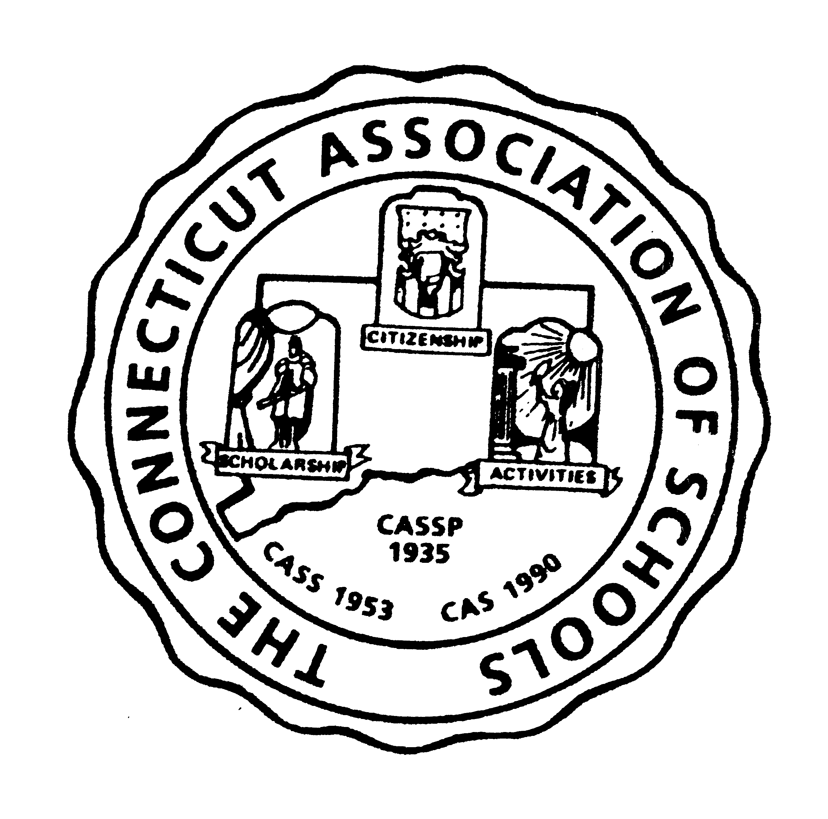
The
Connecticut Association of Schools
Presents
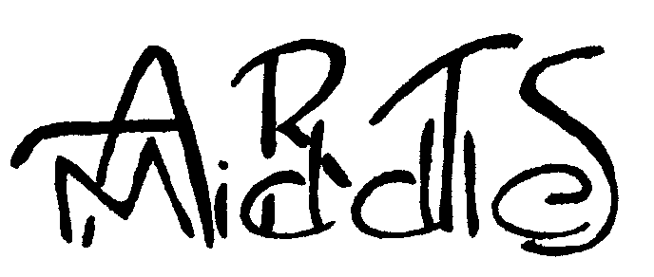
Fourth Annual
MIDDLE SCHOOL

ARTS CONFERENCE
“Hands-on Workshop”
Tuesday, May 17, 2005
University of Hartford’s Art School
8:30 a.m. – 3:00 p.m.

Arts in the Middle
Tuesday, May 17, 2005
University of Hartford’s Art School
8:30 a.m. – 3:00 p.m.

SCHEDULE
Registration 8:30
Workshop Session I 9:00-11:00
Lunch (provided) & Check-in
with chaperone 11:15-12:00
Workshop Session II 12:15-2:15
Walk thru & View Exhibits 2:15-2:45
Collect Art and Departure 2:45-3:00

Feel free to bring a snack and beverage. Lunch is provided
Arts in the Middle
will:
- Give statewide visibility to the fine arts and promote the arts among middle school students
- Provide opportunities for art students from diverse backgrounds to work together
- Offer middle school art students a high caliber artistic challenge
- Give art teachers an opportunity to create their own work

Working artists will lead all these workshops! They’ll be bringing examples of their own work or portfolios. Pick a medium you’ve never tried before or pick a medium you enjoy and want to learn more about. Be prepared to do some great artwork, meet other artists and have fun!! And…you need not bring supplies with you…just BRING A SMOCK!
Workshops
Select 4 workshops and put the letter of each in the workshop preference boxes after your name:
- Portraits
Using black Conte charcoal on Strathmore illustration board, students will create a highly rendered likeness to their subject.
- Plein Aire
Learn methods used by outdoor landscape painting with emphasis on spontaneous impression, capturing light and mood.
- Pastels
Learn and practice pastel method from basic fundamentals using stick and pencil mediums to the finer techniques of chalk.
- Computer Arts
Use an electronic brush to learn the basics of painting without ever touching paint or putting on a smock!
- Drawing
Expressive drawing with line and rhythm. Drawing with live model.
- Cartooning
Working from a storyline, each participant will develop a cartoon character to be put into a comic strip created by each artist.
- Acrylic & Mixed Media
Create a Hip Hop poster using a variety of pencils, markers, paints and collage techniques.
- Wire Sculpture
Bend it! Curve It! Twist it! Explore sculpture through the barest of linear elements.
- Water Color
Develop a painting from a still life or photo. Participants will learn the use of certain brushes, types of paper and development of palettes.
- Aboriginal Art
Apply paint with nontraditional tools and use authentic symbols and elements of Aboriginal art to create a painting.
- Self Portraits
Create a self portrait using collage materials and techniques.
CONFERENCE REGISTRATION FORM

The conference registration fee for CAS middle level member schools is $25.00 per person for one teacher and three students in schools with enrollments up to 500. Schools with enrollments over 500 may send up to two teachers and six students. Because the conference is primarily for students, “Arts in the Middle” cannot accept registrations from teachers only.
Participants from non-member middle schools are welcome with the payment of an additional $100.00 charge per school.
(Please print or type)

School:
Street:
City, Zip:
Phone | Email address for teacher

PARTICIPANTS | Workshops Preferences  1st 2nd 3rd 4th
Art Teacher:
Student:
Student:
Student:

Workshop assignments will be made on a space available basis
Every effort will be made to accommodate at least one of each participant’s top choices
❑ Full payment enclosed (Make check payable to CAS)
❑ PO # _________________ enclosed
Please mail with payment by April 29, 2005 to:

Arts in the Middle
Connecticut Association of Schools
30 Realty Drive
Cheshire, CT 06410
203-250-1111

