All of us are working harder than ever to raise student achievement, meet AYP goals, and reduce the gaps in performance that exist across CT. Yet many of our children are still underachieving. In this workshop, renowned psychologist Michael Whitley will explain why this is so and how we – teachers, administrators, parents – can work smarter and get our kids to work harder to achieve better results.

Included in this workshop will be . . .

- an analysis of the various types of underachievers

- a proven ten-step program to get kids back on track

- “Do’s” and “Don’ts” for both educators and parents

The afternoon session will develop practical guidelines for educators to use in schools; the evening session will focus on guidelines for parents to use in the home. This is a unique opportunity for the school and home to join together in a common approach to improving student achievement.

Please note that the evening session is limited to parents from schools with an administrator attending the afternoon session.

About the Presenter
Michael D. Whitley, Ph.D.

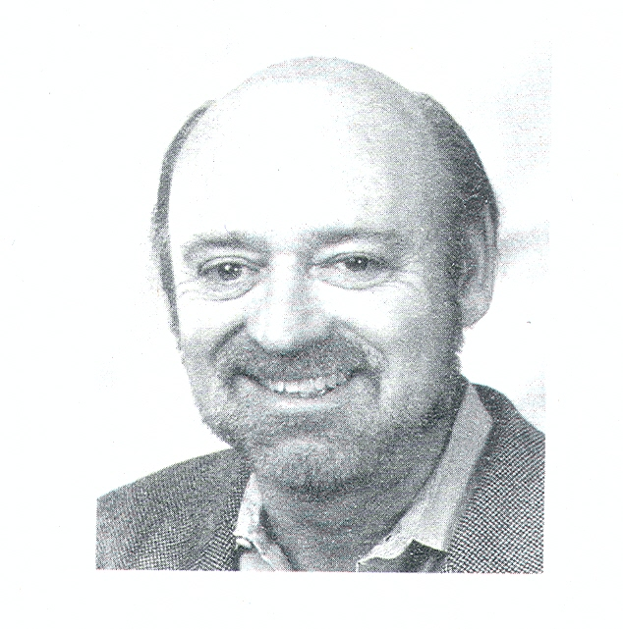

Michael D. Whitley, Ph.D., is a clinical psychologist in Houston, Texas, specializing in motivational difficulties and behavioral problems of children, adolescents, and adults. Over twenty years in practice has provided Dr. Whitley with a unique understanding of this special area of human behavior and, as an author and lecturer, he has shared his insight with the public through books, personal seminars, PBS specials, and radio and television interviews.

Registration Form

Name ______________________________

Position ____________________________

School /District ______________________

Address ____________________________

City ___________State___Zip___________

Phone_______________________________

Email_______________________________

Cost: $50 per educator for the afternoon session; parents from that educator’s school may attend the evening session at no cost.
However, parents must register to attend.

Please mail or fax your registration form by January 27, 2006 to:

Michael Buckley
CAS
30 Realty Drive, Cheshire, CT 06410

(203) 250-1111 Phone
(203) 250-1345 Fax

Email - mbuckley@casciac.org

Or you may register on line at www.casciac.org.

Directions to CAS:

From Danbury and Points West: Take I-84 East to Exit 27 (Route I-691). Take Exit 3 (Route 10) of Route 691. At the end of the ramp, turn right onto Route 10 South. After approximately 1 ½ miles, turn left onto Realty Drive (opposite Highland Bowl).

From Hartford and Points East: Take I-84 West to Exit 27 (Route I-691). Take Exit 3 (Route 10) off Route 691. At the end of the ramp, turn right onto Route 10 South. After approximately 1 ½ miles, turn left onto Realty Drive (opposite Highland Bowl).

From I-91 South or North: Take I-691 in Meriden West to Exit 3 (Route 10). At the end of the ramp, turn left onto Route 10 South. After approximately 1 ½ miles, turn left onto Realty Drive (opposite Highland Bowl).

.2 CEUS will be awarded upon completion of the session

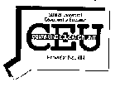


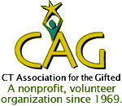
CAS, CAUS, CPTA, and CAG
present

A workshop by Dr.Michael Whitley
Author of
Bright Minds, Poor Grades



Date: February 2, 2006

Location:
CAS, 30 Realty Drive
Cheshire, CT 06410

Time:
3:30-5:30 p.m. - Administrators
7:00-9:00 p.m. – Parents

