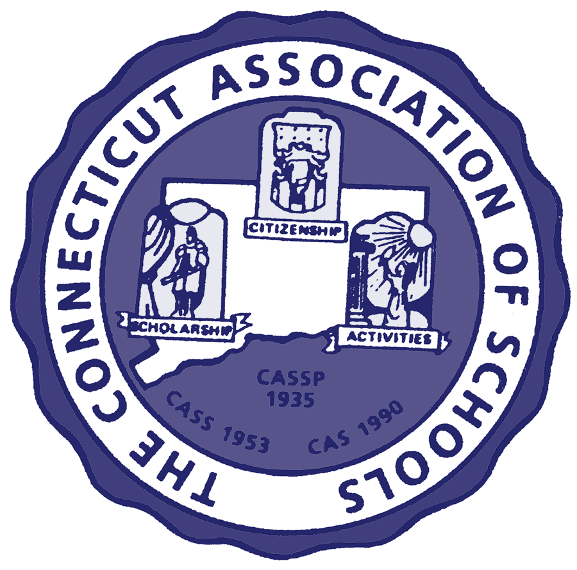
EXECUTIVE DIRECTOR
Michael H. Savage

OFFICERS:

President
V. Everett Lyons, Principal
Bristol Eastern High School

President-Elect
Katharine Bishop, Principal
Daisy Ingraham School, Westbrook

Vice President (High)
Donald Macrino
Waterford High School

Vice President (Middle)
David Russell, Principal
John Winthrop M.S., Deep River

Vice President (Elementary)
Loraine Giannini
ElmerThiennes-Mary Hall School, Marlborough

Secretary-Treasurer
Janet Garagliano, Principal
Jonathan Law High School,
Milford

AFFILIATED WITH:

• National Association of Secondary School Principals

• New England Association of Schools and Colleges

• National Middle School Association

• National Association of Elementary School Principals

• New England League of
Middle Schools

• National Federation of State High School Associations

30 Realty Drive
Cheshire, CT 06410
Phone: (203)250-1111
FAX: (203)250-1345
www.casciac.org
Serving schools
and principals
The Connecticut Association of Schools
Contact: Michael Savage, Executive Director, Connecticut Association of Schools
(203) 250-1111, ext. 3908, msavage@casciac.org
30 Realty Drive, Cheshire, CT 06410 / fax: (203)250-1345

October 14, 2008
FOR IMMEDIATE RELEASE:

CAS TAKES POSITION ON LOWERING THE LEGAL DRINKING AGE

The mission of the Connecticut Association of Schools is to provide exemplary programs and services that promote excellence in the education of all children.

The Connecticut Association of Schools (CAS) is firmly opposed to lowering the legal alcohol drinking age in Connecticut. Further it is opposed to the Amethyst Initiative which is a coalition of 129 college and university presidents who are calling for an "informed and unimpeded debate on the 21-year-old drinking age.” At the heart of the initiative is the desire to reduce the minimum legal drinking age to 18.

Middle school and high school educators across Connecticut are dealing on a daily basis with the devastating results of the underage drinking that now occurs with the minimum legal drinking age of 21. There is clear and convincing evidence that, when the drinking age is lowered, the degree of teenage drinking increases and so, too, does the incidence of suicide, automobile fatalities, alcohol-related injuries, and school drop-outs.

According to statistics from the National Highway Traffic Safety Administration, young drinking drivers are involved in fatal crashes at twice the rate of drivers aged 21 and older.¹ Furthermore, research indicates that, if drinking is delayed until age 21, a child's risk of serious alcohol-related problems is decreased by 70 percent.² Furthermore, when the minimum legal drinking age is 21, people under age 21 drink less overall and continue to do so through their early twenties.³ This is compelling testimony when one considers that the brain continues to develop into the early twenties^{4,5,6,7} and that alcohol use in adolescence has been shown to decrease executive functioning, memory, spatial operations, and attention – all of which are important to academic performance and future functioning.^{8,9,10,11}
The Connecticut Association of Schools understands the challenges that college and university administrators face as a result of the underage drinking that occurs on their campuses. However, lowering the drinking age to 18 only exacerbates the problems secondary school administrators face. Our middle and high school students are at critical stages in their social, emotional, physical and intellectual development; and the degree of maturity of their population creates an even more difficult set of problems than those encountered by college-level students. It is clear that the longer we can postpone the use of alcohol by teenagers, the better opportunity we have to overcome the destructive realities that result from irresponsible alcohol consumption.

CAS would welcome the opportunity to participate in a dialogue on solutions to the problem of underage drinking. However, we stand firmly opposed to any “solution” that involves a reduction in the national minimum legal drinking age.

1 National Highway Traffic Safety Administration (NHTSA). 2000 Youth Fatal Crash and Alcohol Facts. Washington, DC: US Department of Transportation, 2001.

2. Grant BF, Dawson DA. Age at onset of alcohol use and association with DSM-IV alcohol abuse and dependence: Results from the National Longitudinal Alcohol Epidemiologic
Survey. J Subst Abuse 9:103-110, 1997.

3. O’Malley PM and A.C. Wagenaar. “Effects of Minimum Drinking Age Laws on Alcohol Use, Related Behaviors and Traffic Crash Involvement Among American Youth: 1976 –
1987.” J Stud Alcohol (1991): 238-259.

4 Kuhn, Cynthia, Scott Swartzwelder, and Wilkie Wilson. Buzzed: The Straight Facts about the Most Used and Abused Drugs from Alcohol to Ecstasy. New York, NY: W.W. Norton,
1998.

5 Giedd, Jay N. et al. " Brain Development During Childhood and Adolescence: A Longitudinal MRI Study." Nature Neuroscience 2, no. 10, October 1999.

6 Giedd, Jay N. “Structural Magnetic Resonance Imaging of the Adolescent Brain.” Annals of N.Y. Academy of Sciences 1021 (2004): 77–85.

7 White, Aaron M. "Substance Use and Adolescent Brain Development: An Overview of Recent Findings with a Focus on Alcohol." Durham, NC: Duke University Medical Center,
2001.

8 Giancola, P.R., and AC Mezzich. "Neuropsychological deficits in female adolescents with a substance use disorder: Better accounted for by conduct disorder?" Journal of Studies
on Alcohol 61(6) (2000): 809-817.

9 Tapert, S.F. and SA Brown. "Neuropsychological correlates of adolescent substance abuse: Four-year outcomes." Journal of the International Neuropsychological Society 5
(1999): 481-493.

10 Tapert, S.F., et al. "MRI measurement of brain function in alcohol use disordered adolescents." Alcoholism: Clinical and Experimental Research, 25 (2001): 80A.

11 Brown, S.A., et al. "Neurocognitive functioning of adolescents: Effects of protracted alcohol use." Alcoholism: Clinical and Experimental Research 24 (2) (2000): 164-71.

