CIAC CLASS ACT SPORTSMANSHIP BANNER
ORDER FORM
School Name
School Address
Name
Email
Phone

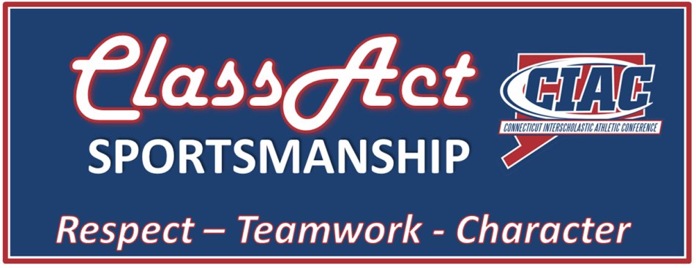
Banner Options
Banner Size | Price | Quantity
2’ x 4’ | $85
3’ x 6’ | $135
4’ x 8’ | $185
+ $15 Shipping and Handling
Fax/Email Order Form to Denis O’Brien (860) 346-1720
Or signsondemandusa@sbcglobal.net
Signs on Demand LLC
777 Laurel Grove Road
Middletown, CT 06457

