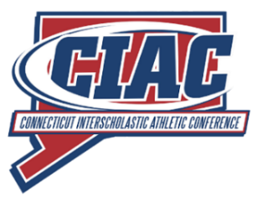

Memo: CIAC Decision To Not Hold A June Scholastic Basketball Event In 2019

From: Glenn Lungarini, Executive Director  
 Gregg Simon, Association Executive Director

The Connecticut Interscholastic Athletic Conference (CIAC) has opted not to run a June scholastic basketball evaluation event in 2019 as permitted by the NCAA and supported by the NFHS. CIAC recognizes the efforts of NFHS in developing criteria, and working with the National High School Basketball Coaches Association (NHSBCA), to suggest five event models state high school associations can use if hosting an event. However, CIAC feels several details remain to be addressed including opportunities for girls during this time period, funding associated with running such an event, and selection of participants. Also, it is our understanding that the NCAA will be hosting basketball recruiting events in July at regional locations around the country, with one location being the University of Connecticut (UCONN). Therefore, CIAC will observe the process used by states choosing to run a June event in 2019, as well as the NCAA sponsored July event at UCONN, this year. We look forward to learning from the experiences of state high school associations around the country and further collaboration between the NFHS and the NCAA.

**OFFICERS:**

**Chair**

Anthony Azzara

Sacred Heart High School, Waterbury

**Vice Chair**

Sheila Riffle, Principal

Old Saybrook High School

**Secretary**

Matt Ryan

East Hartford High School

**Treasurer**

Dr. Beth Smith

Shelton High School

**CENTRAL OFFICE**

**STAFF:**

**Executive Director**

Glenn Lungarini

**Associate Executive Director**

Gregg Simon

**Directors of Marketing**

Stephanie Ford

Mary Lee Weber

**Executive Staff**

Joel Cookson

Matthew Fischer

Dr. Robert Lehr

Joseph Tonelli

**Unified Sports®**

Robert Hale, Jr.

Paul Mengold

George Synnott

**The CT Interscholastic**

**Athletic Conference**

30 Realty Drive

Cheshire, CT 06410

Phone: (203)250-1111

FAX: (203)250-1345

ciacsports.com



Affiliated with the National Federation of State High School Associations