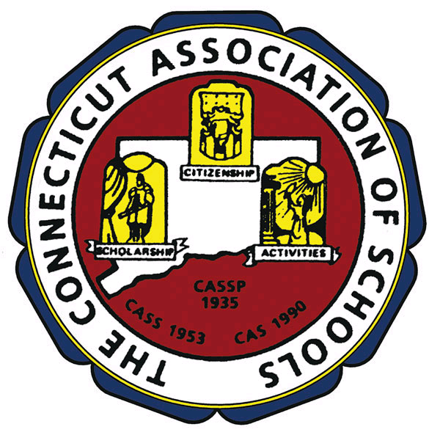

CAS Elementary Division Upcoming Events For 2009-2010

--SAVE THE DATES—

September, 2009 Reading Program with UCONN Women’s Basketball Team

October 21, 2009 Middle School Unified Sports Soccer and Elementary Skills, New
Canaan Country Day School, 3:30 to 6:00 pm

November 21, 2009 Elementary Unified Sports Day, Bacon Academy, Colchester,
10:00 am to 12:30 pm
November 23, 2009 Elementary Program Recognition Banquet, Aqua Turf

January, 2010 Elementary Leadership Conference, Enfield
January, 2010 Elementary Leadership Conference, Waterbury
Elementary Leadership Conference, Groton (Date TBA)
January, 2010 Celebration: Reading Program/UCONN Women’s Basketball Team

February 2, 2010 Elementary Celebration of the Arts, Aqua Turf
February 3, 2010 Elementary Celebration of the Arts, Aqua Turf
February 4, 2010 Snow Date Elementary Celebration of the Arts

March 16, 2010 Elementary Parent/Volunteer Banquet, Aqua Turf

April 9-12, 2010 NAESP Convention, Houston, Texas
April 10, 2010 Elementary Unified Sports Day, Glastonbury, 10:00 am to 12:30 pm

May 1, 2010 Elementary Unified Sports Day, Conard High School, West
Hartford, 10:00 am to 12:30 pm
May 15, 2010 Elementary Unified Sports Day, New Haven Field House,
10:00 am to 12:30 pm
May, 2010 Marine Science Day
May, 2010 KiDSMARATHON
___________________________________________________________________________

CAS Elementary Awards: Due Dates:

Elementary School of the Year September 11, 2009
Outstanding First-Year Principal Award September 11, 2009
National Distinguished Principal (NDP) Award December 14, 2009
Exemplary Educator of the Year Award February 26, 2010
Elementary School Climate Award See Website

For Additional Award Information Check the CAS Website at www.casciac.org

