DIRECTIONS:

UNIVERSITY OF CONNECTICUT,
AVERY POINT CAMPUS, GROTON, CONNECTICUT
Go to: www.uconn.edu

Or if selected for the CONNECTICUT RIVER MUSEUM, ESSEX, CONNECTICUT
Go to: www.ctrivermuseum.org

REGISTRATION

Registrants will be accepted on a first-come, first-serve basis. A lottery system will be used for the Project Oceanology’s Enviro-lab boat.

*Each student attending must have a photo disclaimer on file at their school.
*All Students will receive a complimentary backpack.

All Schools MUST register on-line at
www.casciac.org/register.

Bring registration confirmation with you to the
conference

Registration Fee:
CAS Member School Fee: $80.00
CAS Non-Member School Fee: $160.00

Payment must be received by May 1, 2008

Mail to:
Connecticut Association of Schools
Marine Science Day
30 Realty Drive, Cheshire, CT 06410
Attention: Barbara O’Connor

MARINE SCIENCE DAY
CONFERENCE COMMITTEE

Susan McNamara
Long Island Sound Foundation
Executive Director

Jay Brennan
Paul E. Chatfield School, Seymour

Pat Ruane
St. Augustine Cathedral School, Fairfield
Deborah Friday
Rocky Hill
Louis Pear
CT Association of Schools
Assistant Executive Director
Barbara Peck
Webster Hill School, West Hartford
Teresa Wilson
Myrtle Stevens School, Rocky Hill

THE REASONS WHY

The purpose of this conference is to educate students about Long Island Sound and Marine Science. Each student will be individually scheduled to participate in a series of workshops presented by university personnel, graduate students, and environmental educators from a variety of organizations and institutions. These workshops will promote a greater awareness of Long Island Sound and Marine Science.

The Long Island Sound Foundation in conjunction with the CT Association of Schools and the CT River Museum

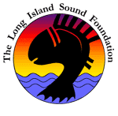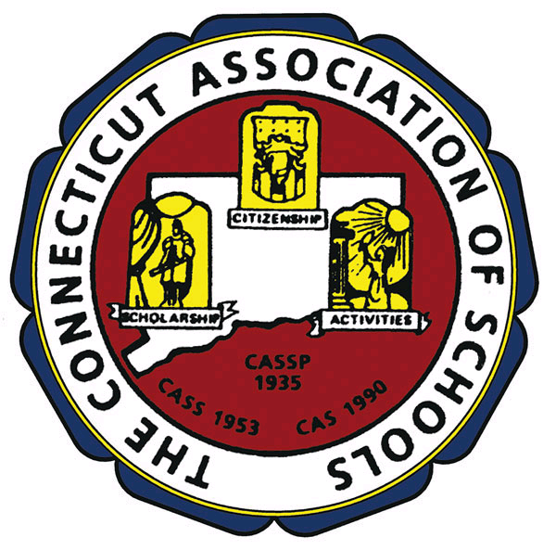

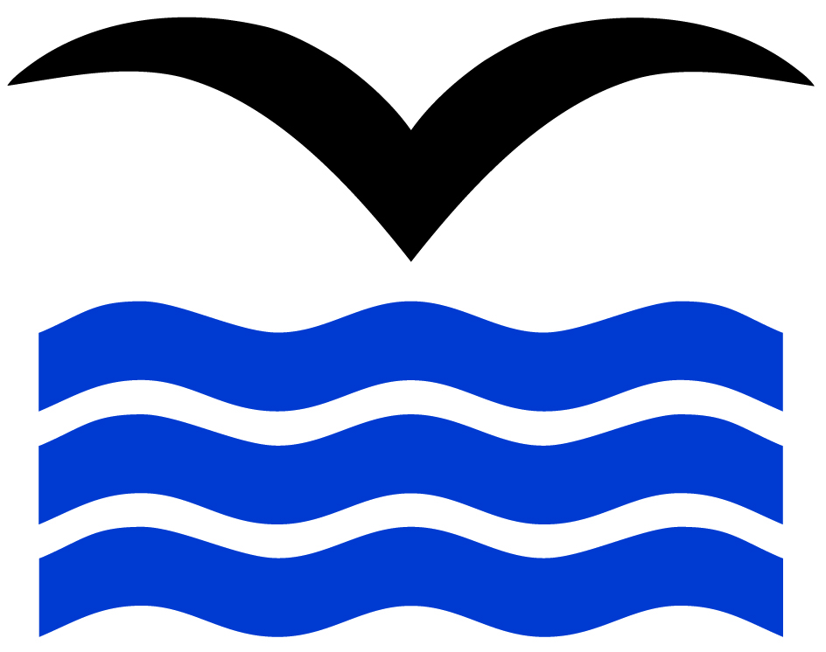
Connecticut River Museum

Presents
MARINE SCIENCE DAY

At Avery Point in Groton and
CT River Museum in Essex

For 5th - 8th Grade Students

Wednesday, May 14, 2008
9:00am – 3:00pm

This year the Long Island Sound Foundation will provide a grant to selected schools for half their transportation cost plus reimbursement for their student registration.
Following the event, teachers may submit one page on why their school should be selected to qualify for this grant.

- Teachers must collaborate with their students.
- What was their learning experience at Marine Science Day?
____________________________________

An outreach program has been added to Marine Science Day at the Connecticut River Museum. 72 students will be selected for this program on the river and the watershed. A detailed program will be provided to the selected schools.

Each student must bring lunch and a snack.

The committee encourages each student to pack a lunch that will generate the least amount of trash. Bring your own beverage. (No glass containers.)

Students should dress for hands-on activities,
i.e., outdoors, boat trip and classroom floor, etc.

Materials will be handed out at workshops.

AVERY POINT PROGRAM

8:30-9:30 Registration
9:45–10:30 Session I
10:40-11:25 Session II
11:35-12:20 Session III (Lunch)
12:30-1:15 Session IV (Lunch)
1:25-2:10 Session V
2:20-3:00 Closing Ceremony

Special Presentation by Mallory Bagwell, Mime Performing Artist

RIVER MUSEUM PROGRAM

8:30 – 9:30 Registration
9:30 – 2:30 Programs
River Dwellers
Wild River on vessel RiverQuest
Something Fishy

SPONSORS

Long Island Sound Foundation
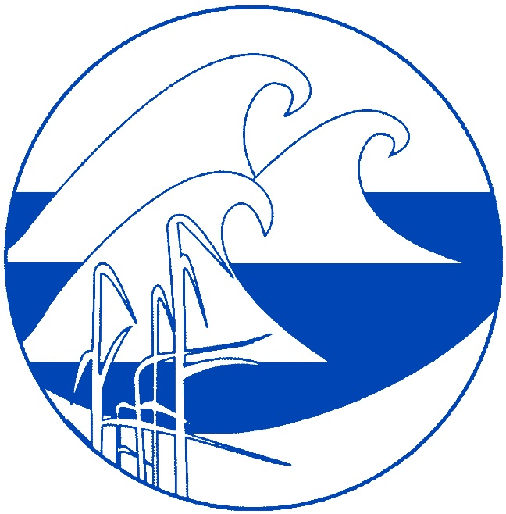
Project Oceanology



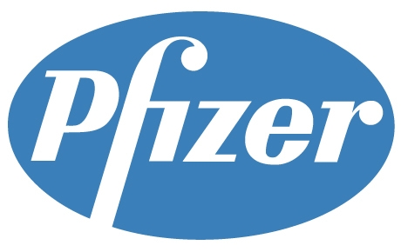

H O S T
