CAS Competitive Grant Application
Special Education Coaching Support For
Administrators

Connecticut Association of Schools
Contact: Marie Salazar Glowski
E-Mail: mglowski@casciac.org
Electronic Copy Due Date: August 24, 2021
Hard Copy Due Date: August 31, 2021

30 REALTY DRIVE, CHESHIRE, CT 06410
PHONE: 203.250.1111 | FAX: 203.250.1345
www.casciac.org

Affirmative Action Statement

The Connecticut Association of Schools and all contractors and subcontractors who do business with the Connecticut Association of Schools are committed to providing equal opportunities in employment to all qualified persons solely on the basis of job-related skills, ability and merit.

The Connecticut Association of Schools will continue to take affirmative action to ensure that no persons are discriminated against with regard to race, color, sex, sexual orientation, national origin, ancestry, religion, age, physical disability, mental retardation, marital status, present or past history of mental disorder, learning disability or criminal record. The Connecticut Association of Schools will continue to make good faith efforts to comply with all federal and state laws and policies which speak to Equal Employment Opportunity and Affirmative Action.

This Policy Statement is based on both the spirit and the letter of state and federal anti-discrimination laws, regulations and executive orders. Accordingly, care is taken to ensure that no person shall be excluded from participation in, be denied the benefits of, or otherwise be unlawfully discriminated against. Further, the Connecticut Association of Schools will not knowingly use the services of, patronize or otherwise deal with any business, contractor, subcontractor or agency that engages in acts of unlawful discrimination.

AN EQUAL OPPORTUNITY/AFFIRMATIVE ACTION EMPLOYER

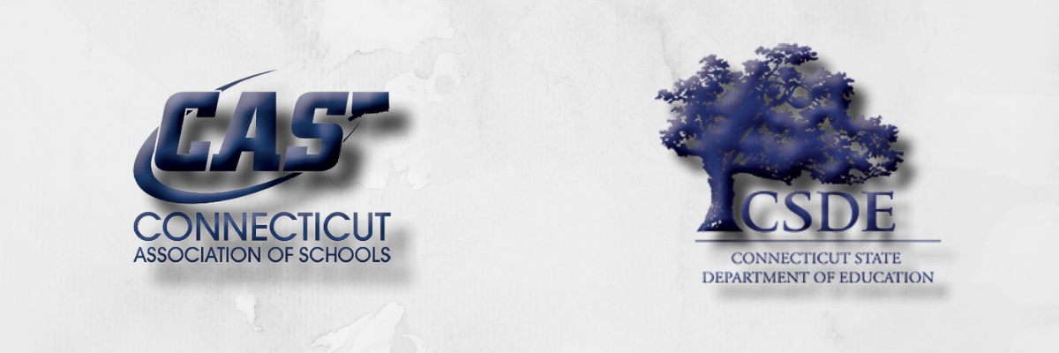

TABLE OF CONTENTS

BACKGROUND FOR DEVELOPMENT OF GRANT page 3
gRANT INFORMATION Page 4-5
GRANT APPLICANT INSTRUCTIONS PAGE 6
ASSURANCES page 7

BACKGROUND FOR DEVELOPMENT OF GRANT

The Connecticut State Department of Education (CSDE), Bureau of Special Education and the Connecticut Association of Schools (CAS) partnership

This special education executive coaching model has been developed as a result of many requests from the field indicating that special education and other administrators would benefit greatly from the support of an executive coach with special education expertise. It was determined the CSDE would support this model through an application process made available to districts. Grant awardees will receive a coach at no cost for the services provided.

The primary focus of coaching support will be to assist with the ongoing challenges posed by the COVID-19 pandemic. Additionally, coaches will work with administrators to enhance time management, organizational skills and communication strategies. Differentiated support will be provided as determined by the administrator based upon the individual, school and/or district needs. Possible outcomes may include an improved COVID-19 response; increased job effectiveness; improved staff satisfaction and retention; timely responses and resolutions to compliance related matters; improved staff and family communication; and increased parent satisfaction. It is anticipated that the coach will assist the administrator in achieving a successful reopen of schools while managing special education requirements that support effective programming and services for students with disabilities.

Through this grant, the CSDE and CAS will work collaboratively with partner districts to:

- Support a new or experienced administrator overseeing special education matters;
- Create a plan to support administrator through challenges related to COVID-19;
- Build capacity for supporting accelerated and equitable learning experiences for all students, particularly, students with disabilities; and
- Enhance district capacity for implementing and sustaining successful practices that are developed throughout the year by providing training, technical assistance and resources to identified administrators.

GRANT INFORMATION

Services will be provided at no cost to the districts that are awarded the grant.

SCOPE OF SERVICES

- CAS Executive Coach

- A coach with special education expertise will be assigned to the administrator who is applying for this grant. The coach will meet with the administrator for up to 10 days during the grant period.
- The coach will become familiar with the district’s special education department and together with the administrator will develop an action plan.
- The coach will provide technical assistance and strategies to implement the plan and achieve the goals within the plan.
- The coach will be available by email and phone between district, school and virtual visits.

- Project updates and end of the year summary

- The coach will submit logs providing an overview of activities, questions and feedback and a self reflection of each session to include its outcomes and next steps.
- An end of the year report will be provided to each administrator, which will document activities related to the structured individualized support plan inclusive of an action plan for next steps.
GRANT PERIOD
The grant period will end June 30, 2022.
GRANT AWARD
The CSDE and CAS reserve the right to award this grant in a manner deemed to be in the best interest of the district and its students.

GRANT APPLICATION SCHEDULE
Release of Grant Application: | 08/12/21
Electronic Grant Application Due Date: | 08/24/21

MINIMUM REQUIREMENTS
The CSDE and CAS will review all grant applications. The following information, in addition to the requirements, terms and conditions identified throughout this document, will be considered as part of the selection process.

Selection Criteria:

- Submission of grant application with responses to all questions
- Other information and signatures as requested

Questions may be submitted in writing to:
Marie Salazar Glowski, Director of Executive Coaching, Connecticut Association of Schools – mglowski@casciac.org.
GRANT APPLICATION SUBMISSION
Electronic copy submitted by August 24, 2021 and sent to mglowski@casciac.org. Extensions may be granted.
All hard copy responses to this solicitation must be submitted as follows:
two (2) complete copies and received by August 31, 2021, at 4:00 PM at:

Connecticut Association of Schools
c/o Marie Salazar Glowski, Director of Executive Coaching
30 Realty Drive
Cheshire, CT 06410

GRANT APPLICANT INSTRUCTIONS
The administrator who will receive a coach must address the following:

- Organizational information – Name and title of the administrator who is applying and the number of years in the position, number of special education administrators in the department, composition of pupil personnel staff and number of schools.
Name of Administrator who is applying
Title
Location where applicant has office
Name of Special Education Director if different from applicant
District
Address
School/District Telephone Number at which the applicant may be reached
Cell Phone Number
Applicant Email Address
Years in Position
Number of special education administrators in the district
Number of schools in district

- Describe how the administrator and all stakeholders will benefit from having a coach to support a transition plan as schools reopen.

- Describe how this project will have a positive impact on students and has the potential to transform the culture of the department, school and/or the district.

- Expected goals - List 2 goals that you hope will be achieved throughout the year as a result of the administrator working with a coach.

5 How will the applicant work with the district/school during the implementation of the grant project to sustain positive results beyond the close of the grant period?

APPENDIX

Statement of Assurances
PROJECT: The Connecticut Association of Schools Special Education Executive Coaching Grant:
THE APPLICANT, ____________________________, HEREBY ASSURES THAT:

1. The applicant has the necessary legal authority to submit a grant application.

2. The filing of this grant application has been duly authorized to file this application for and on behalf of said applicant.
3. The activities and services for which assistance will be provided under this grant will be under the control of the applicant.

4. The project will be operated in compliance with all applicable state and federal laws and in compliance with the regulations and other policies and administrative directives of the CAS and the CSDE.

5. The administrator and coach will provide an end-of-year report (within 30 days of the project completion), as specified by CAS. Overall satisfaction with the services provided will be included.

6. CAS reserves the exclusive right to use and grant the right to use and/or publish any part or parts of any summary, reports and materials resulting from this project.

7. The applicant will protect and save harmless the CAS from financial loss and expense, including fees and legal fees and costs, if any, arising out of any breach of the duties, in whole or in part, described in the application and in the contract, if awarded;

I, the undersigned authorized official, hereby certify that these assurances shall be fully implemented.
Signature_____________________________________________________________
(By signing this electronically you confirm that this is your signature.)

Name (typed)__________________________________________________________

Title (typed) ___________________________________________________________

Name of District ___________________________________Date ________________

Telephone #______________________________________

